Artistverse
Test Record
Nichakamol  Watcharit | Sanghong 642115015
 | Srichai | 642115041
Bachelor of Science
Software Engineering Program
Department College of Arts, Media, and
Technology
Chiang Mai University
October 2024
Project Advisor
Asst. Prof. Pattama Longani, Ph.D.

Document History
Document  Name | Version | History | Status | Date | Editable | Reviewer
Artistverse-  TestRecord | Artistverse-  TestRecord  V.0.1 | Add Chapter 1  • Purpose  • Acronyms andDefinitions  Add Chapter 2  Test  Responsibility  Add Chapter 3  Test Record  • Unit Test  Record  • System Test  Record  • Appendix | Draft | 26/06/2024 | NS,WS | PL
Artistverse-  TestRecord | Artistverse-  TestRecord  V.0.2 | Update Chapter1  • Purpose  • Acronyms andDefinitions  Update Chapter2 Test  Responsibility  Update Chapter3 Test Record  • Unit Test  Record  • System Test  Record  • Appendix | Edit | 26/06/2024 | NS,WS | PL

Document  Name | Artistverse-TestRecord  V.3.0 | Owner | NS , WS | Page | 2
Document  Type | Test Record | Release Date | 11/10/2024 | Print date | 11/10/2024

Artistverse-  TestRecord | Artistverse-  TestRecord  V.1.0 | Update Chapter1  • Purpose  • Acronyms andDefinitions  Update Chapter2 Test  Responsibility  Update Chapter3 Test Record  • Unit Test  Record  • System Test  Record  • Appendix | Edit | 28/06/2024 | NS,WS | PL
Artistverse-  TestRecord | Artistverse-  TestRecord  V.1.1 | Add  Progress II  Chapter 3 Test  Record  • Unit Test  Record  • System Test  Record  • Appendix | Draft | 28/08/2024 | NS, WS | PL
Artistverse-  TestRecord | Artistverse-  TestRecord  V.1.2 | Edit  Progress II  Chapter 3 Test  Record  • Unit Test  Record  • System Test  Record  • Appendix | Edit | 30/08/2024 | NS, WS | PL

Document  Name | Artistverse-TestRecord  V.3.0 | Owner | NS , WS | Page | 3
Document  Type | Test Record | Release Date | 11/10/2024 | Print date | 11/10/2024

Artistverse-  TestRecord | Artistverse-  TestRecord  V.2.0 | Edit  Progress II  Chapter 3 Test  Record  • Unit Test  Record  • System Test  Record  • Appendix | Publis  h | 30/08/2024 | NS, WS | PL
Artistverse-  TestRecord | Artistverse-  TestRecord  V.3.0 | Publish  document  version 3.0 | Publis  h | 11/10/2024 | NS, WS | PL

Document  Name | Artistverse-TestRecord  V.3.0 | Owner | NS , WS | Page | 4
Document  Type | Test Record | Release Date | 11/10/2024 | Print date | 11/10/2024

Chapter 1 Introduction
1.1 Purpose and Scope
The purpose of the Test Record document is to record the actual result, and pass / fail
criteria of each test case that has been designed in the test plan and executed for the
Artistverse system.
1.2 Acronyms and Definitions
Acronyms
URS | User Requirement Specification
UTC | Unit Test Case
STC | System Test Case
TD | Test Data
Definition
Name | Definition
IEEE | Institute for Electrical and Electronics Engineers. Biggest global interest  group for engineers of different branches and computer scientists. [1]
Plan | A document series of tasks requires meeting an objective, typically  including the associated schedule, budget, resources, organizational  description and work breakdown structure. [1]
Feature | Feature Transformation of input parameters to output parameters based  on a specified algorithm. It describes the functionality of the product in  the language of the product. Used for requirements analysis, design,  coding, testing or maintenance. [1]
Project  Management | The application of knowledge, skills, tools, and techniques to project  activities in order to meet or exceed stakeholder needs and expectations  from a project. [1]

Document  Name | Artistverse-TestRecord  V.3.0 | Owner | NS , WS | Page | 5
Document  Type | Test Record | Release Date | 11/10/2024 | Print date | 11/10/2024

Project Plan | A formal, approved document used to guide both project execution and  project control. The primary uses of the project plan are to document  planning assumptions and the decision, to facilitate communication  among stakeholders, and to document approved scope, cost, and  schedule baseline. [1]
Risk | An uncertain event or condition that, if it occurs, has a positive or  negative effect on a project’s objectives. It is a function of the  probability of occurrence of a given threat’s occurrence. [1]
Risk  Management | The systematic application of management policies, procedures and  practices to the tasks of identifying, analyzing, evaluating, treating and  monitoring risk. [1]
System Testing | Testing conducted on a complete and integrated system for evaluate the  system’s compliance with its specified requirements. [1]
Unit Test | A test of individual programs or modules in order to remove a design or  programming errors. [1]
Traceability | The ability to trace the history, application or location of an item or  activity, or work products or activities, by means of recorded  identification. The establishment and maintenance of relationships  between such items. Horizontal traceability describes the relationship  between work products of the same type (e.g. Customer requirements).  Vertical traceability describes the relationship between work products,  which build or derived from each other (e.g., from customer  requirements to qualification test cases). Bidirectional traceability  allows to directly following relationships in both directions. [1]
Use Case | A use case is a description of a specific interaction between a system  and its users to accomplish a particular goal or task. It outlines the  sequence of steps or actions that a user performs in the system and  describes the system's responses to those actions. Use cases help to  identify and define the functional requirements of a system from the  perspective of its users.

Document  Name | Artistverse-TestRecord  V.3.0 | Owner | NS , WS | Page | 6
Document  Type | Test Record | Release Date | 11/10/2024 | Print date | 11/10/2024

Activity  Diagram | Activity diagram is another important behavioral diagram in UML  diagram to describe dynamic aspects of the system. Activity diagram is  essentially an advanced version of flow chart that modeling the flow  from one activity to another activity.
Chapter 2 Test Responsibility
Name | Responsibility
Record Unit Test | NS,WS
Record System Test | NS,WS
*NS = Nichakamol Sanghong
*WS = Watcharit Srichai
Document  Name | Artistverse-TestRecord  V.3.0 | Owner | NS , WS | Page | 7
Document  Type | Test Record | Release Date | 11/10/2024 | Print date | 11/10/2024

Chapter 3 Unit Test Record
3.1 Progress I
UTC-01: Test generate_lyrics_genre
Test ID: UTC-01
Test Function: generate_lyrics_genre(prompt,genre,language)
Test Cases:
ID | Description | Input | Expected Result | result
1 | Verify that the  system generates  lyrics based on the  input provided by  the songwriter. | {  "prompt": "My  love",  "genre": "pop", "language":  "English"  } | {  "lyrics": "Verse 1:\nYou're the  light that leads me  home\nThrough the storm, you'renever gone\nHeart to heart, we'llnever part\nMy love for you willnever fall apart\nChorus:\nMylove, my love, shining like the  stars above\nIn your arms, I  found my place\nMy love, my  love, brighter than the moonlitlace\nIn your embrace, I foundmy grace\nVerse 2:\nEvery day,you're by my side\nIn your love,I wanna hide\nWords can't  describe what I feel\nWith you,everything is real\nChorus:\nMylove, my love, shining like the  stars above\nIn your arms, I  found my place\nMy love, my  love, brighter than the moonlitlace\nIn your embrace, I foundmy grace\nBridge:\nSo hold meclose, never let me go\nIn yourlove, I've found my  glow\nForever and always, by  your side\nMy love for you, it  will never subside\nChorus:\nMylove, my love, shining like the | pass

Document  Name | Artistverse-TestRecord  V.3.0 | Owner | NS , WS | Page | 8
Document  Type | Test Record | Release Date | 11/10/2024 | Print date | 11/10/2024

stars above\nIn your arms, I
found my place\nMy love, my
love, brighter than the moonlit
lace\nIn your embrace, I foundmy grace"
}

Document  Name | Artistverse-TestRecord  V.3.0 | Owner | NS , WS | Page | 9
Document  Type | Test Record | Release Date | 11/10/2024 | Print date | 11/10/2024

UTC-02: Test generate_lyrics_mood
Test ID: UTC-02
Test Function: generate_lyrics_mood(prompt,mood,language)
Test Case:
ID | Description | Input | Expected Result | result
1 | Verify that the  system generates  lyrics based on the  input provided by  the songwriter. | {  "prompt": "My  love",  "mood":  "Romantic",  "language":  "English"  } | {  "lyrics": "Verse 1:\nMy  love, like a star in the  night\nShining bright, yourlove is my guiding  light\nEvery moment with  you feels so right\nIn your  arms, I find my  paradise\nChorus:\nMy love,my love, you're my  everything\nIn your  embrace, my heart begins tosing\nWith every kiss, my  soul takes flight\nYou're theone who makes my world sobright"  } | pass
2 | Verify that the  system displays anerror message if theprompt is missing. | {  "prompt": "",  "mood":  "Romantic",  "language":  "English"  } | {  "errors": {  "prompt": "Please input a  lyric topic."  }  } | pass
3 | Verify that the  system displays anerror message if themood is not  selected. | {  "prompt": "My  love",  "mood": "",  "language":  "English" | {  "errors": {  "mood": "Please select a  mood."  }  } | pass

 |  | }
4 | Verify that the  system displays anerror message if thelanguage is not  selected. | {  "prompt": "My  love",  "mood":  "Romantic",  "language": ""  } | {  "errors": {  "language": "Please select  a language."  }  } | pass
5 | Verify that the  system displays anerror message if  there is no internet  connection. | {  "prompt": "My  love",  "mood":  "Romantic",  "language":  "English"  } | {  "error": "Internet no  connection", "message":  "Unable to compose lyrics" } | pass

Document  Name | Artistverse-TestRecord  V.3.0 | Owner | NS , WS | Page | 11
Document  Type | Test Record | Release Date | 11/10/2024 | Print date | 11/10/2024

UTC-03: Test generate_lyrics_artist
Test ID: UTC-03
Test Function: generate_lyrics_artist(prompt,artist,language)
Test Cases:
ID | Description | Input | Expected Result | result
1 | Verify that the  system generates  lyrics based on the  input provided by  the songwriter. | {  "prompt": "My  love",  "artist": "TaylorSwift",  "language":  "English"  } | {  "lyrics": "Verse 1:\nYou were  the one I thought I'd never  find\nCaught in a moment, lostin your eyes\nEvery little thingabout you, every little smile\nIknew right then, you were worththe while\nPre-Chorus:\nIt's likeI'm living in a fairytale\nWithyou by my side, I'll never  fail\nYou're the melody in myheart's refrain\nI'm falling for  you, again and  again\nChorus:\nMy love, like aTaylor Swift song\nIn every  word, you belong\nYou're the  sweetest melody, my favorite  line\nMy love, in every song,  you shine\nVerse 2:\nYou're thehand that fits perfectly in  mine\nIn your arms, all the starsalign\nEvery time you whispermy name\nIt's like the whole  world's never the  same\nPre-Chorus:\nIt's like I'mliving in a fairytale\nWith youby my side, I'll never  fail\nYou're the melody in myheart's refrain\nI'm falling for  you, again and  again\nChorus:\nMy love, like aTaylor Swift song\nIn every  word, you belong\nYou're the  sweetest melody, my favorite | pass

Document  Name | Artistverse-TestRecord  V.3.0 | Owner | NS , WS | Page | 12
Document  Type | Test Record | Release Date | 11/10/2024 | Print date | 11/10/2024

line\nMy love, in every song,
you shine\nBridge:\nEvery beat,every rhyme, you're my
sweetest inspiration\nIn everylove ballad, you're my perfectcreation\nChorus:\nMy love,
like a Taylor Swift song\nIn
every word, you belong\nYou'rethe sweetest melody, my
favorite line\nMy love, in everysong, you shine"
}

Document  Name | Artistverse-TestRecord  V.3.0 | Owner | NS , WS | Page | 13
Document  Type | Test Record | Release Date | 11/10/2024 | Print date | 11/10/2024

UTC-04: Test validateForm()
Test ID: UTC-04
Test Function: validateForm()
Test Cases:
ID | Description | Input | Expected Result | result
1 | When all fields  (prompt, artist, andlanguage) are  empty, the  validateForm  function should  return false and setthe errors object  with appropriate  error messages for  each missing field. | this.prompt = '';  this.artist = '';  this.language = ''; | this.errors = {  prompt: "Please input a lyric  topic.",  artist: "Please select an artist.", language: "Please select a  language."  };  return false; | pass
2 | When the prompt  field is empty but  artist and languagefields are filled, thevalidateForm  function should  return false and setthe errors object  with an appropriateerror message for  the missing promptfield. | this.prompt = '';  this.artist =  'Taylor swift';  this.language =  'English'; | this.errors = {  prompt: "Please input a lyrictopic."  };  return false; | pass
3 | When the artist fieldis empty but promptand language fieldsare filled, the  validateForm  function should  return false and setthe errors object  with an appropriateerror message for | this.prompt =  'Love';  this.artist = '';  this.language =  'English'; | this.errors = {  artist: "Please select an artist."};  return false; | pass

Document  Name | Artistverse-TestRecord  V.3.0 | Owner | NS , WS | Page | 14
Document  Type | Test Record | Release Date | 11/10/2024 | Print date | 11/10/2024

the missing artist
field.
4 | When the languagefield is empty but  prompt and artist  fields are filled, thevalidateForm  function should  return false and setthe errors object  with an appropriateerror message for  the missing  language field. | this.prompt =  'Love';  this.artist =  'Taylor swift';  this.language = ''; | this.errors = {  language: "Please select a  language."  };  return false; | pass

Document  Name | Artistverse-TestRecord  V.3.0 | Owner | NS , WS | Page | 15
Document  Type | Test Record | Release Date | 11/10/2024 | Print date | 11/10/2024

UTC-05: Save lyrics
Test ID: UTC-05
Test Function: saveLyrics()
Test Cases:
ID | Description | Input | Expected Result | result
1 | Verify that the  generated lyrics aresaved to the local  computer in a .txt  file when the "Save"button is clicked. | 1. Generate lyricsusing UC-02,  UC-03, or  UC-04.  2. Display the  generated lyrics  to the songwriter.3. The songwriterclicks the "Save"button. | - The .txt file containing the  generated lyrics is saved to thelocal computer.  - No error messages are  displayed. | pass
2 | Verify that the  "Save" button is  displayed after the  lyrics are generated. | 1. Generate lyricsusing UC-02,  UC-03, or  UC-04.  2. Display the  generated lyrics  to the songwriter. | - The "Save" button is visibleand clickable. | pass
3 | Verify that an errormessage is  displayed if there isno internet  connection when  trying to save the  lyrics. | 1. Generate lyricsusing UC-02,  UC-03, or  UC-04.  2. Display the  generated lyrics  to the songwriter.3. The songwriterclicks the "Save"button. | - An error message "Unable tosave lyrics" is displayed.  - The use case ends without  saving the lyrics. | pass

Document  Name | Artistverse-TestRecord  V.3.0 | Owner | NS , WS | Page | 16
Document  Type | Test Record | Release Date | 11/10/2024 | Print date | 11/10/2024

UTC-06: Test get_music_recommendations
Test ID: UTC-06
Test Function: get_music_recommendations()
Prepared data:
● | Appendix A:Spotify_track
Test Cases:
ID | Description | Input | Expected Result | result
1 | This will test the  scenario where the  emotion detection  returns null. | “emotion”: null | {  "emotion": null,  "error": "Mood could not be  detected, Try again",  "songs": []  } | pass
2 | This will test the  scenario where the  detected emotion is  "Happy". | “emotion”:  “Happy” | {  "emotion": "Happy",  "songs":  "[{\"Name\":\"seaside_demo\",\"Album\":\"seaside_demo\",\"Artist\":\"SEB\",\"Image\":\"https:\/\/i.scdn.co\/image\/ab67616d0000b2738e7fc05a3d8a67f93f589016\",\"Spotify_link\":\"https:\/\/open.spotify.com\/track\/73M0rMVx5CWE8M4uATSsto\"},{\"Name\":\"Souvenir\",\"Album\":\"Souvenir\",\"Artist\":\"MRTOUT LE  MONDE\",\"Image\":\"https:\/\/i.scdn.co\/image\/ab67616d0000b27375400d96819719b1b395a326\",\"Spotify_link\":\"https:\/\/open.spotify.com\/track\/3ZAtgPjqwwxxvXk9mbUeFX\"},{\"Name\":\"Treasure\",\"Album\":\"Treasure\",\"Artist\":\"MR | pass

Document  Name | Artistverse-TestRecord  V.3.0 | Owner | NS , WS | Page | 17
Document  Type | Test Record | Release Date | 11/10/2024 | Print date | 11/10/2024

TOUT LE
MONDE\",\"Image\":\"https:\/\/i.scdn.co\/image\/ab67616d0000b2736b32f60d7e839985caf30679\",\"Spotify_link\":\"https:\/\/open.spotify.com\/track\/0CFDOgUcUUngd612sIAjyF\"},{\"Name\":\"5th
Avenue\",\"Album\":\"5th
Avenue\",\"Artist\":\"Trinix\",\"Image\":\"https:\/\/i.scdn.co\/image\/ab67616d0000b273d29351972b495d943ec0f2c6\",\"Spotify_link\":\"https:\/\/open.spotify.com\/track\/0mpkpO26XkXjT5t3vyl8PA\"},{\"Name\":\"doucevalse\",\"Album\":\"HOTEL
CHOPIN\",\"Artist\":\"Two
Muses
After\",\"Image\":\"https:\/\/i.scdn.co\/image\/ab67616d0000b27362cc2ef7641b5c40b4063113\",\"Spotify_link\":\"https:\/\/open.spotify.com\/track\/18EBIqGYHjF5MoXvw8OAhr\"},{\"Name\":\"Peaches (feat. Daniel
Caesar &
Giveon)\",\"Album\":\"Justice\",\"Artist\":\"Justin
Bieber\",\"Image\":\"https:\/\/i.scdn.co\/image\/ab67616d0000b273e6f407c7f3a0ec98845e4431\",\"Spotify_link\":\"https:\/\/open.spotify.com\/track\/4iJyoBOLtHqaGxP12qzhQI\"},{\"Name\":\"Keep On
Trying\",\"Album\":\"Keep OnTrying\",\"Artist\":\"Mizmo\",\"Image\":\"https:\/\/i.scdn.co\/image\/ab67616d0000b27320095a8e9b89ff529b8dce8f\",\"Spotify_link\":\"https:\/\/open.spotify.com\/track\/2XWV1kIh4nth7BbpUjd371\"},{\"Name\":\"My
Love\",\"Album\":\"My

Document  Name | Artistverse-TestRecord  V.3.0 | Owner | NS , WS | Page | 18
Document  Type | Test Record | Release Date | 11/10/2024 | Print date | 11/10/2024

Love\",\"Artist\":\"Moment inTime\",\"Image\":\"https:\/\/i.scdn.co\/image\/ab67616d0000b273c3a36d58f59f25c50458bdbd\",\"Spotify_link\":\"https:\/\/open.spotify.com\/track\/5o6SMJaMQqDdG21ypMH6js\"},{\"Name\":\"I Can't Help But
Feel\",\"Album\":\"I Can't HelpBut
Feel\",\"Artist\":\"Surfaces\",\"Image\":\"https:\/\/i.scdn.co\/image\/ab67616d0000b273096bdd36203732c8c070ce2a\",\"Spotify_link\":\"https:\/\/open.spotify.com\/track\/40gooTta3y4FgzXaMOGDJL\"},{\"Name\":\"I FeelGood\",\"Album\":\"I Feel
Good\",\"Artist\":\"Pink
Sweat$\",\"Image\":\"https:\/\/i.scdn.co\/image\/ab67616d0000b27320aeb4e7d30db34d04601209\",\"Spotify_link\":\"https:\/\/open.spotify.com\/track\/3lUQpvfWFcxZC3RYAVGE7F\"},{\"Name\":\"Shine\",\"Album\":\"Shine\",\"Artist\":\"Broken
Back\",\"Image\":\"https:\/\/i.scdn.co\/image\/ab67616d0000b2739ae8c466423786ba54d2c0af\",\"Spotify_link\":\"https:\/\/open.spotify.com\/track\/5LI5DHVYrtMKJQaedaUhTS\"},{\"Name\":\"Kiss Me More (feat.
SZA)\",\"Album\":\"Kiss Me
More (feat.
SZA)\",\"Artist\":\"Doja
Cat\",\"Image\":\"https:\/\/i.scdn.co\/image\/ab67616d0000b2736c031afd210aed3084f80956\",\"Spotify_link\":\"https:\/\/open.spotify.com\/track\/748mdHapucXQri7IAO8yFK\"},{\"Name\":\"You Let Me
Leave\",\"Album\":\"How It

Document  Name | Artistverse-TestRecord  V.3.0 | Owner | NS , WS | Page | 19
Document  Type | Test Record | Release Date | 11/10/2024 | Print date | 11/10/2024

Used To
Be\",\"Artist\":\"Snazzy\",\"Image\":\"https:\/\/i.scdn.co\/image\/ab67616d0000b273764c405547eff6ffcd8418e1\",\"Spotify_link\":\"https:\/\/open.spotify.com\/track\/1qpsofJala45QFepOTMPB1\"},{\"Name\":\"It's So
Simple\",\"Album\":\"It's So
Simple\",\"Artist\":\"Mizmo\",\"Image\":\"https:\/\/i.scdn.co\/image\/ab67616d0000b273303a191814e33cb9d3adcf58\",\"Spotify_link\":\"https:\/\/open.spotify.com\/track\/3L4jHpBf2gil2kUYFcYVxO\"},{\"Name\":\"THATS WHAT I
WANT\",\"Album\":\"MONTERO\",\"Artist\":\"Lil Nas
X\",\"Image\":\"https:\/\/i.scdn.co\/image\/ab67616d0000b273be82673b5f79d9658ec0a9fd\",\"Spotify_link\":\"https:\/\/open.spotify.com\/track\/0e8nrvls4Qqv5Rfa2UhqmO\"},{\"Name\":\"Away From
Home\",\"Album\":\"Away
From
Home\",\"Artist\":\"Broken
Back\",\"Image\":\"https:\/\/i.scdn.co\/image\/ab67616d0000b273ec4f3e039a3ebe76454f21b9\",\"Spotify_link\":\"https:\/\/open.spotify.com\/track\/03m9IVJBNQ1nEunB5W3IhM\"}]"
}
3 | This will test the  scenario where the  detected emotion is  "Sad". | “emotion”:  “Sad” | {  "emotion": "Sad",  "songs": "[{\"Name\":\"Too  Sweet\",\"Album\":\"Unheard\",\"Artist\":\"Hozier\",\"Image\":\"https:\/\/i.scdn.co\/image\/ab67616d0000b273be392334d99f82 | pass

Document  Name | Artistverse-TestRecord  V.3.0 | Owner | NS , WS | Page | 20
Document  Type | Test Record | Release Date | 11/10/2024 | Print date | 11/10/2024

bc410cb239\",\"Spotify_link\":\"https:\/\/open.spotify.com\/track\/3HMY0r2BAdpasXMY8rseR0\"},{\"Name\":\"Someone
You
Loved\",\"Album\":\"DivinelyUninspired To A Hellish
Extent\",\"Artist\":\"Lewis
Capaldi\",\"Image\":\"https:\/\/i.scdn.co\/image\/ab67616d0000b273fc2101e6889d6ce9025f85f2\",\"Spotify_link\":\"https:\/\/open.spotify.com\/track\/7qEHsqek33rTcFNT9PFqLf\"},{\"Name\":\"Slipping Through My
Fingers\",\"Album\":\"SlippingThrough My
Fingers\",\"Artist\":\"Declan
McKenna\",\"Image\":\"https:\/\/i.scdn.co\/image\/ab67616d0000b2733c8d171d9b4954a7614bebcf\",\"Spotify_link\":\"https:\/\/open.spotify.com\/track\/5GRarkYarOgejsLCxLprQD\"},{\"Name\":\"Lonely\",\"Album\":\"Trouble Deluxe
Edition\",\"Artist\":\"Akon\",\"Image\":\"https:\/\/i.scdn.co\/image\/ab67616d0000b2736ec7ab30397ea37295340a41\",\"Spotify_link\":\"https:\/\/open.spotify.com\/track\/4v7DCN09hgXkKazefkznDQ\"},{\"Name\":\"WEALWAYS
KNEW\",\"Album\":\"WE
ALWAYS
KNEW\",\"Artist\":\"TOFU
(TH)\",\"Image\":\"https:\/\/i.scdn.co\/image\/ab67616d0000b273219b43f9eb1dfa80ef580039\",\"Spotify_link\":\"https:\/\/open.spotify.com\/track\/4rF1g157m2RG9N7NNrZJSo\"},{\"Name\":\"Love In The
Dark\",\"Album\":\"25\",\"Artist

Document  Name | Artistverse-TestRecord  V.3.0 | Owner | NS , WS | Page | 21
Document  Type | Test Record | Release Date | 11/10/2024 | Print date | 11/10/2024

\":\"Adele\",\"Image\":\"https:\/\/i.scdn.co\/image\/ab67616d0000b2737b9888dc365b8f957c63df14\",\"Spotify_link\":\"https:\/\/open.spotify.com\/track\/0DuWDLjriRPjDRoPgaCslY\"},{\"Name\":\"Sparks\",\"Album\":\"Parachutes\",\"Artist\":\"Coldplay\",\"Image\":\"https:\/\/i.scdn.co\/image\/ab67616d0000b2733d92b2ad5af9fbc8637425f0\",\"Spotify_link\":\"https:\/\/open.spotify.com\/track\/7D0RhFcb3CrfPuTJ0obrod\"},{\"Name\":\"Angels Like You\",\"Album\":\"PlasticHearts\",\"Artist\":\"Miley
Cyrus\",\"Image\":\"https:\/\/i.scdn.co\/image\/ab67616d0000b2738cffb7c6c40759eaf8a5a142\",\"Spotify_link\":\"https:\/\/open.spotify.com\/track\/1daDRI9ahBonbWD8YcxOIB\"},{\"Name\":\"Tell Me\",\"Album\":\"A
Brief
Nirvana\",\"Artist\":\"Khamari\",\"Image\":\"https:\/\/i.scdn.co\/image\/ab67616d0000b27380ef43aafbc204f8640d7470\",\"Spotify_link\":\"https:\/\/open.spotify.com\/track\/52pwE5qBPMXFObPTfk6cfb\"},{\"Name\":\"Cruel\",\"Album\":\"She Loves MeNot\",\"Artist\":\"Jeff
Bernat\",\"Image\":\"https:\/\/i.scdn.co\/image\/ab67616d0000b27351b63a14f5b0bfb09676b13b\",\"Spotify_link\":\"https:\/\/open.spotify.com\/track\/3G52hYnIgyNvPKvPnlhOXM\"},{\"Name\":\"It Will
Rain\",\"Album\":\"It Will
Rain\",\"Artist\":\"Bruno
Mars\",\"Image\":\"https:\/\/i.scdn.co\/image\/ab67616d0000b273dec2e6bae5062b94fc4eeb84\",

Document  Name | Artistverse-TestRecord  V.3.0 | Owner | NS , WS | Page | 22
Document  Type | Test Record | Release Date | 11/10/2024 | Print date | 11/10/2024

\"Spotify_link\":\"https:\/\/open.spotify.com\/track\/0M3HkE321xpCbCYqVKzr1q\"},{\"Name\":\"Past Lives\",\"Album\":\"PastLives\",\"Artist\":\"sapientdream\",\"Image\":\"https:\/\/i.scdn.co\/image\/ab67616d0000b273e17498b2a89c000a29bbd209\",\"Spotify_link\":\"https:\/\/open.spotify.com\/track\/3oELxRDbAzyvOodhd5FQzB\"},{\"Name\":\"Out of
Time\",\"Album\":\"Dawn
FM\",\"Artist\":\"The
Weeknd\",\"Image\":\"https:\/\/i.scdn.co\/image\/ab67616d0000b2734ab2520c2c77a1d66b9ee21d\",\"Spotify_link\":\"https:\/\/open.spotify.com\/track\/2SLwbpExuoBDZBpjfefCtV\"},{\"Name\":\"Always Remember Us
This Way\",\"Album\":\"A StarIs Born Soundtrack (Without
Dialogue)\",\"Artist\":\"Lady
Gaga\",\"Image\":\"https:\/\/i.scdn.co\/image\/ab67616d0000b273b5d4b4ed17ec86c4b3944af2\",\"Spotify_link\":\"https:\/\/open.spotify.com\/track\/2rbDhOo9Fh61Bbu23T2qCk\"},{\"Name\":\"Bad
Habit\",\"Album\":\"Bad
Habit\",\"Artist\":\"Steve
Lacy\",\"Image\":\"https:\/\/i.scdn.co\/image\/ab67616d0000b2739904ecb0b1148a128bdd5e36\",\"Spotify_link\":\"https:\/\/open.spotify.com\/track\/5CM4UuQ9Gnd6K2YyKGPMoK\"},{\"Name\":\"Romantic
Homicide\",\"Album\":\"Petalsto
Thorns\",\"Artist\":\"d4vd\",\"Image\":\"https:\/\/i.scdn.co\/image\/ab67616d0000b27364fa1bd

Document  Name | Artistverse-TestRecord  V.3.0 | Owner | NS , WS | Page | 23
Document  Type | Test Record | Release Date | 11/10/2024 | Print date | 11/10/2024

a999f4fbd2b7c4bb7\",\"Spotify_link\":\"https:\/\/open.spotify.com\/track\/0SCLsDJtC7DmOwks1tsszt\"}]"
}
4 | This will test the  scenario where the  detected emotion is  "Angry". | “emotion”:  “Angry” | {  "emotion": "Angry",  "songs":  "[{\"Name\":\"Nightmare\",\"Album\":\"Nightmare\",\"Artist\":\"Halsey\",\"Image\":\"https:\/\/i.scdn.co\/image\/ab67616d0000b2730db100d30d1ef9a91aefeabf\",\"Spotify_link\":\"https:\/\/open.spotify.com\/track\/340UVheS8z3ncW9TTUhAbc\"},{\"Name\":\"Last Laugh - From  \\\"Promising Young Woman\\\"Soundtrack\",\"Album\":\"Promising Young Woman (OriginalMotion Picture  Soundtrack)\",\"Artist\":\"Various  Artists\",\"Image\":\"https:\/\/i.scdn.co\/image\/ab67616d0000b273ced3e09e03f023fd028c6964\",\"Spotify_link\":\"https:\/\/open.spotify.com\/track\/3DfTZtNNSDBV10YMu9JFWF\"},{\"Name\":\"Bust Your  Windows\",\"Album\":\"Fearless\",\"Artist\":\"Jazmine  Sullivan\",\"Image\":\"https:\/\/i.scdn.co\/image\/ab67616d0000b273ebcc9144c41ae7d42efe6d94\",\"Spotify_link\":\"https:\/\/open.spotify.com\/track\/56z2qI0gKcPthQF6l8AW3E\"},{\"Name\":\"hostage\",\"Album\":\"dont  smile at me\",\"Artist\":\"BillieEilish\",\"Image\":\"https:\/\/i.scdn.co\/image\/ab67616d0000b273a9f6c04ba168640b48aa5795\ | pass

Document  Name | Artistverse-TestRecord  V.3.0 | Owner | NS , WS | Page | 24
Document  Type | Test Record | Release Date | 11/10/2024 | Print date | 11/10/2024

",\"Spotify_link\":\"https:\/\/open.spotify.com\/track\/1WsEgieHsWWndAzLkmV105\"},{\"Name\":\"Fly On The
Wall\",\"Album\":\"Breakout\",\"Artist\":\"Miley
Cyrus\",\"Image\":\"https:\/\/i.scdn.co\/image\/ab67616d0000b273e345458751c029f411db3d5b\",\"Spotify_link\":\"https:\/\/open.spotify.com\/track\/2f6s0AcBRBE0vIOU0NMdXw\"},{\"Name\":\"Midnight
Sky\",\"Album\":\"Midnight
Sky\",\"Artist\":\"Miley
Cyrus\",\"Image\":\"https:\/\/i.scdn.co\/image\/ab67616d0000b273d59c3c489691c8b41043cab2\",\"Spotify_link\":\"https:\/\/open.spotify.com\/track\/27ycaQnQAxaPiyeg3nr2aB\"},{\"Name\":\"Miss Jackson (feat.
LOLO)\",\"Album\":\"Too
Weird to Live, Too Rare to
Die!\",\"Artist\":\"Panic! At TheDisco\",\"Image\":\"https:\/\/i.scdn.co\/image\/ab67616d0000b2733d01f39642426b65217fbe21\",\"Spotify_link\":\"https:\/\/open.spotify.com\/track\/46Kcradxrva9Dny4lHU1b3\"},{\"Name\":\"Heart-Shaped
Box\",\"Album\":\"In Utero
(Deluxe
Edition)\",\"Artist\":\"Nirvana\",\"Image\":\"https:\/\/i.scdn.co\/image\/ab67616d0000b273aca059cebc1841277db22d1c\",\"Spotify_link\":\"https:\/\/open.spotify.com\/track\/11LmqTE2naFULdEP94AUBa\"},{\"Name\":\"Therefore I
Am\",\"Album\":\"Therefore IAm\",\"Artist\":\"Billie
Eilish\",\"Image\":\"https:\/\/i.sc

Document  Name | Artistverse-TestRecord  V.3.0 | Owner | NS , WS | Page | 25
Document  Type | Test Record | Release Date | 11/10/2024 | Print date | 11/10/2024

dn.co\/image\/ab67616d0000b2737a152619a7b55bc621d07901\",\"Spotify_link\":\"https:\/\/open.spotify.com\/track\/54bFM56PmE4YLRnqpW6Tha\"},{\"Name\":\"you should see me in a
crown\",\"Album\":\"WHEN
WE ALL FALL ASLEEP,
WHERE DO WE
GO?\",\"Artist\":\"Billie
Eilish\",\"Image\":\"https:\/\/i.scdn.co\/image\/ab67616d0000b27350a3147b4edd7701a876c6ce\",\"Spotify_link\":\"https:\/\/open.spotify.com\/track\/3XF5xLJHOQQRbWya6hBp7d\"},{\"Name\":\"Tommy\",\"Album\":\"Tommy
Genesis\",\"Artist\":\"TommyGenesis\",\"Image\":\"https:\/\/i.scdn.co\/image\/ab67616d0000b273f9b11cd892ee0f2e3f428620\",\"Spotify_link\":\"https:\/\/open.spotify.com\/track\/3y4eLP5IRnGhERGtdvfBsi\"},{\"Name\":\"Tag, You're
It\",\"Album\":\"Cry Baby
(Deluxe
Edition)\",\"Artist\":\"MelanieMartinez\",\"Image\":\"https:\/\/i.scdn.co\/image\/ab67616d0000b2733899712512f50a8d9e01e951\",\"Spotify_link\":\"https:\/\/open.spotify.com\/track\/3u1FiuSpfsgVnekEMXgMwJ\"},{\"Name\":\"Better By
Myself\",\"Album\":\"Better ByMyself\",\"Artist\":\"Hey
Violet\",\"Image\":\"https:\/\/i.scdn.co\/image\/ab67616d0000b2731004e4f6ab87c4c8734b592a\",\"Spotify_link\":\"https:\/\/open.spotify.com\/track\/77ixMBo91onYG37mAZiaUj\"},{\"Name\":\"Ain't

Document  Name | Artistverse-TestRecord  V.3.0 | Owner | NS , WS | Page | 26
Document  Type | Test Record | Release Date | 11/10/2024 | Print date | 11/10/2024

Shit\",\"Album\":\"Planet
Her\",\"Artist\":\"Doja
Cat\",\"Image\":\"https:\/\/i.scdn.co\/image\/ab67616d0000b273be841ba4bc24340152e3a79a\",\"Spotify_link\":\"https:\/\/open.spotify.com\/track\/5lAnYvAIkSDNXqfo7DyFUm\"},{\"Name\":\"Hurts Like Hell (feat.
Offset)\",\"Album\":\"Hurts
Like Hell (feat.
Offset)\",\"Artist\":\"MadisonBeer\",\"Image\":\"https:\/\/i.scdn.co\/image\/ab67616d0000b27362866f0eb635492c8915a746\",\"Spotify_link\":\"https:\/\/open.spotify.com\/track\/3WefHNGtjexZvi66ZEx9u4\"},{\"Name\":\"Ex's &
Oh's\",\"Album\":\"Love
Stuff\",\"Artist\":\"Elle
King\",\"Image\":\"https:\/\/i.scdn.co\/image\/ab67616d0000b273eb5a4a3ad6b9548ce4ca2c03\",\"Spotify_link\":\"https:\/\/open.spotify.com\/track\/70eDxAyAraNTiD6lx2ZEnH\"}]"
}

Document  Name | Artistverse-TestRecord  V.3.0 | Owner | NS , WS | Page | 27
Document  Type | Test Record | Release Date | 11/10/2024 | Print date | 11/10/2024

3.2 Progress II
UTC-01: Test analyzeLyrics()
Test ID: UTC-01
Test Function: analyzeLyrics(lyrics)
Return Type: String
Test Cases:
ID | Description | Input | Expected Result | Result
1 | Verify that the  system analyze  valid lyrics and  provide analysis | {  "lyrics": "[Verse  1] When you  were here beforeCouldn't look youin the eye You'rejust like an angelYour skin makesme cry You floatlike a feather In abeautiful world Iwish I was  special You're sofuckin' special  [Chorus] But I'ma creep, I'm a  weirdo What thehell am I doin'  here? I don't  belong here  [Verse 2] I don't  care if it hurts I  wanna have  control I want a  perfect body I  want a perfect  soul I want you tonotice When I'mnot around You'reso fuckin' special | {  "analysis": "Your lyricssuggest a sense of  longing and an  introspective,  melancholic mood.  Here's a suggestion fora musical  interpretation:\n\n-  Chords: The song couldbe accompanied by  simple, arpeggiated  chords, such as G, B, C,and Cm, to capture theemotional depth of thelyrics.\n\n- Key: The  song could be in the  key of G major,  providing a  melancholic yet hopefulfeel.\n\n- Time  Signature: The lyrics  lend themselves well toa 4/4 time signature,  allowing for a  comfortable and naturalflow of the  melody.\n\n- Tempo: Aslow tempo, around  60-70 beats per minute, | pass

Document  Name | Artistverse-TestRecord  V.3.0 | Owner | NS , WS | Page | 28
Document  Type | Test Record | Release Date | 11/10/2024 | Print date | 11/10/2024

 |  | I wish I was  special [Chorus]But I'm a creep,  I'm a weirdo  What the hell amI doin' here? I  don't belong hereOh-oh, oh-oh"  } | would enhance the  emotional impact of thelyrics and the  contemplative nature ofthe song.\n\n- MusicalInformation: The versescould feature a  minimalistic, gentle  guitar arpeggio  accompanied by a  melancholic vocal  melody. The chorus  might build with a  slightly fuller  arrangement, adding  gentle percussion and  additional  instrumentation to  convey the emotional  intensity. Overall, the  music should capture  the vulnerability and  longing expressed in  the lyrics."  }

Document  Name | Artistverse-TestRecord  V.3.0 | Owner | NS , WS | Page | 29
Document  Type | Test Record | Release Date | 11/10/2024 | Print date | 11/10/2024

3.2 Progress II
UTC-07: Test analyzeLyrics()
Test ID: UTC-07
Test Function: analyzeLyrics(lyrics)
Return Type: String
Test Cases:
ID | Description | Input | Expected Result | Result
1 | Verify that the  system analyze  valid lyrics and  provide analysis | {  "lyrics": "[Verse  1] When you  were here beforeCouldn't look youin the eye You'rejust like an angelYour skin makesme cry You floatlike a feather In abeautiful world Iwish I was  special You're sofuckin' special  [Chorus] But I'ma creep, I'm a  weirdo What thehell am I doin'  here? I don't  belong here  [Verse 2] I don't  care if it hurts I  wanna have  control I want a  perfect body I  want a perfect  soul I want you tonotice When I'mnot around You'reso fuckin' special | {  "analysis": "Your lyricssuggest a sense of  longing and an  introspective,  melancholic mood.  Here's a suggestion fora musical  interpretation:\n\n-  Chords: The song couldbe accompanied by  simple, arpeggiated  chords, such as G, B, C,and Cm, to capture theemotional depth of thelyrics.\n\n- Key: The  song could be in the  key of G major,  providing a  melancholic yet hopefulfeel.\n\n- Time  Signature: The lyrics  lend themselves well toa 4/4 time signature,  allowing for a  comfortable and naturalflow of the  melody.\n\n- Tempo: Aslow tempo, around  60-70 beats per minute, | pass

Document  Name | Artistverse-TestRecord  V.3.0 | Owner | NS , WS | Page | 30
Document  Type | Test Record | Release Date | 11/10/2024 | Print date | 11/10/2024

 |  | I wish I was  special [Chorus]But I'm a creep,  I'm a weirdo  What the hell amI doin' here? I  don't belong hereOh-oh, oh-oh"  } | would enhance the  emotional impact of thelyrics and the  contemplative nature ofthe song.\n\n- MusicalInformation: The versescould feature a  minimalistic, gentle  guitar arpeggio  accompanied by a  melancholic vocal  melody. The chorus  might build with a  slightly fuller  arrangement, adding  gentle percussion and  additional  instrumentation to  convey the emotional  intensity. Overall, the  music should capture  the vulnerability and  longing expressed in  the lyrics."  }

Document  Name | Artistverse-TestRecord  V.3.0 | Owner | NS , WS | Page | 31
Document  Type | Test Record | Release Date | 11/10/2024 | Print date | 11/10/2024

Chapter 4 System Test Record
4.1 Progress I
STC-01: Access Lyric Generation Options
Description: This system verifies that the navbar and lyrics generator page correctlydisplay options for the songwriter to compose lyrics based on various criteria,including genre, mood, and artist style.
Prepared Data:
Test script:
1. Open the Artistverse website in a web browser.
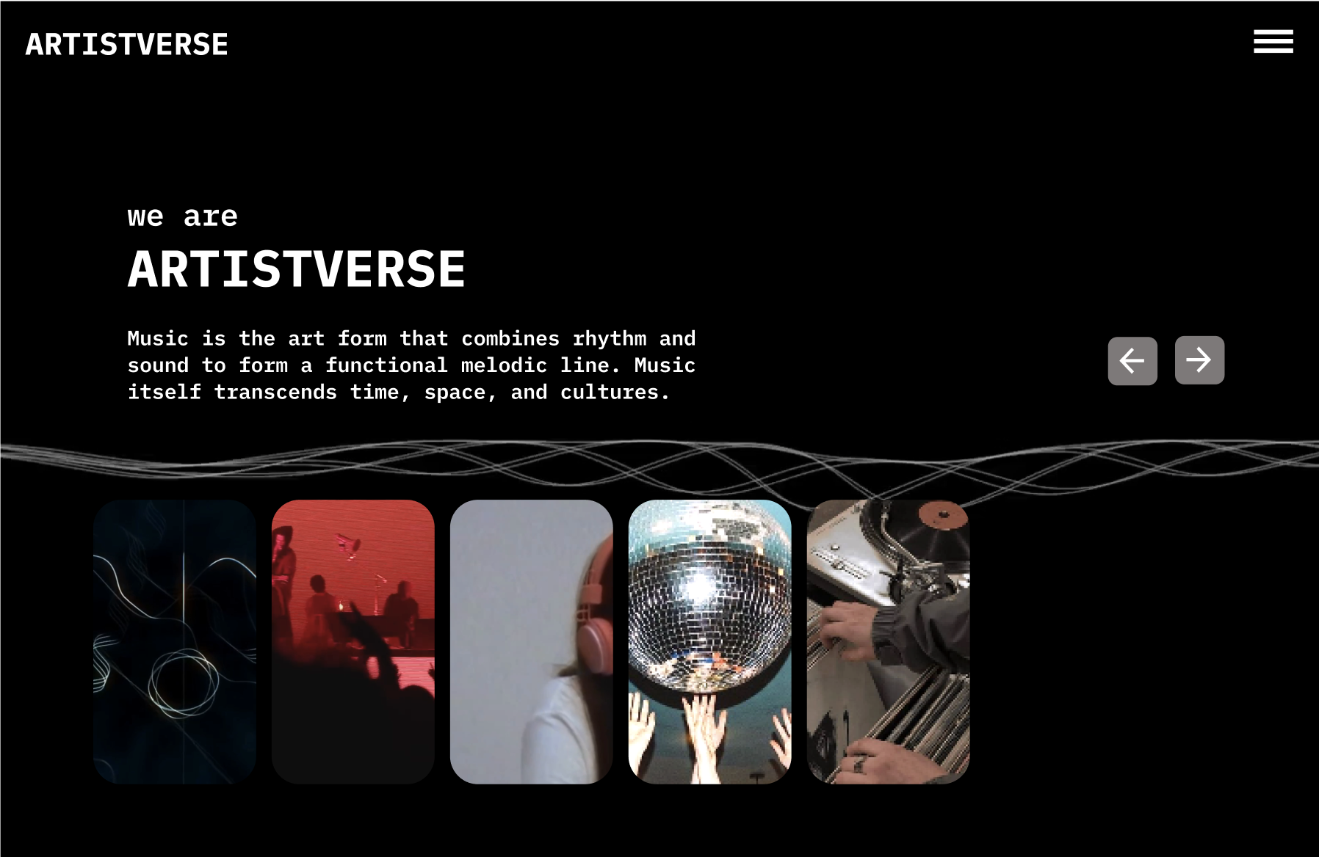
2. Click the "navbar-toggler-icon" button.
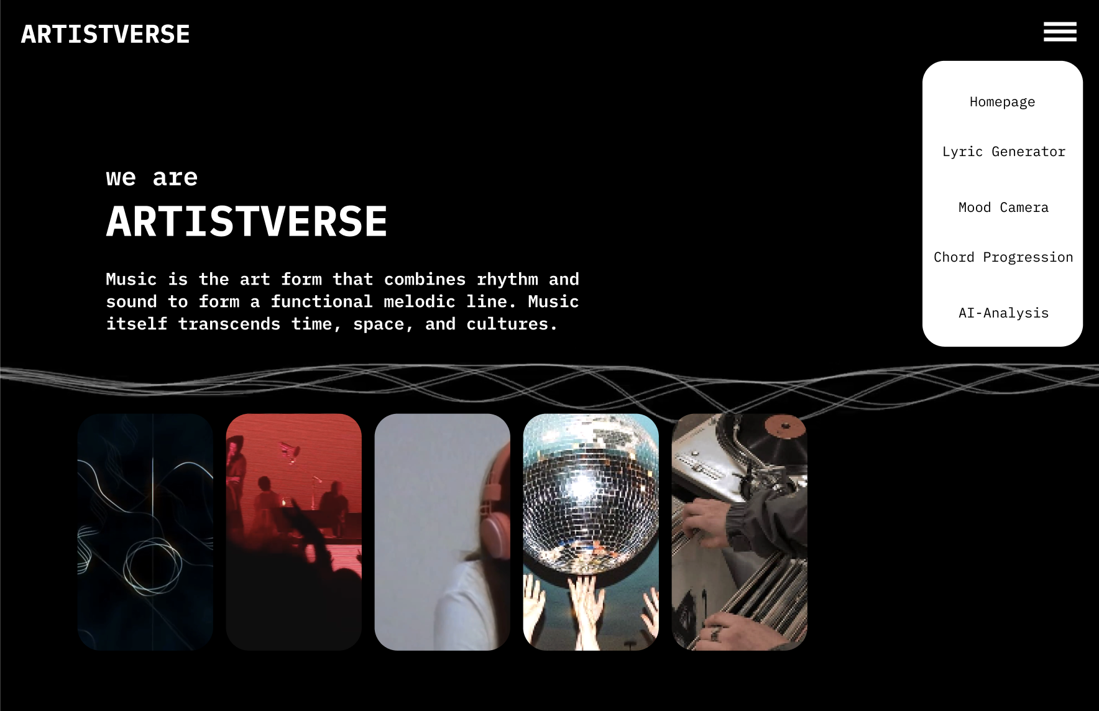

3. The system displays a drop-down menu with options: "Homepage", "Lyric
Generator", "Mood Camera", "Chord Progression", and "AI-Analysis".

4. Select "Lyric Generator" from the dropdown menu.


5. The system redirects to the Lyric Generator page.
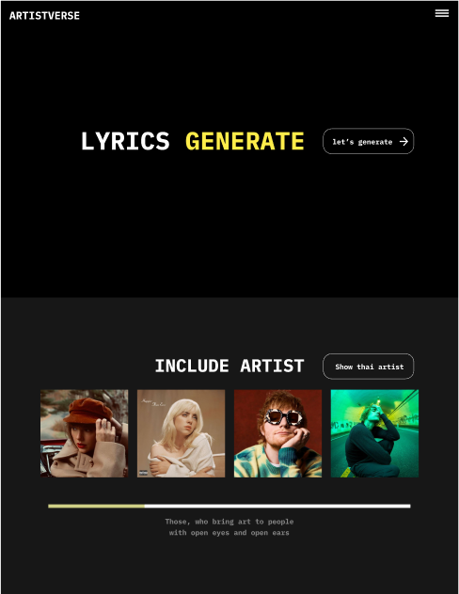
6. Click on the "Let's Generate" button.


7. The system displays options for composing lyrics: "Lyric Generator by Genre", "Lyric
Generator by Mood", and "Lyric Generator by Style Artist".
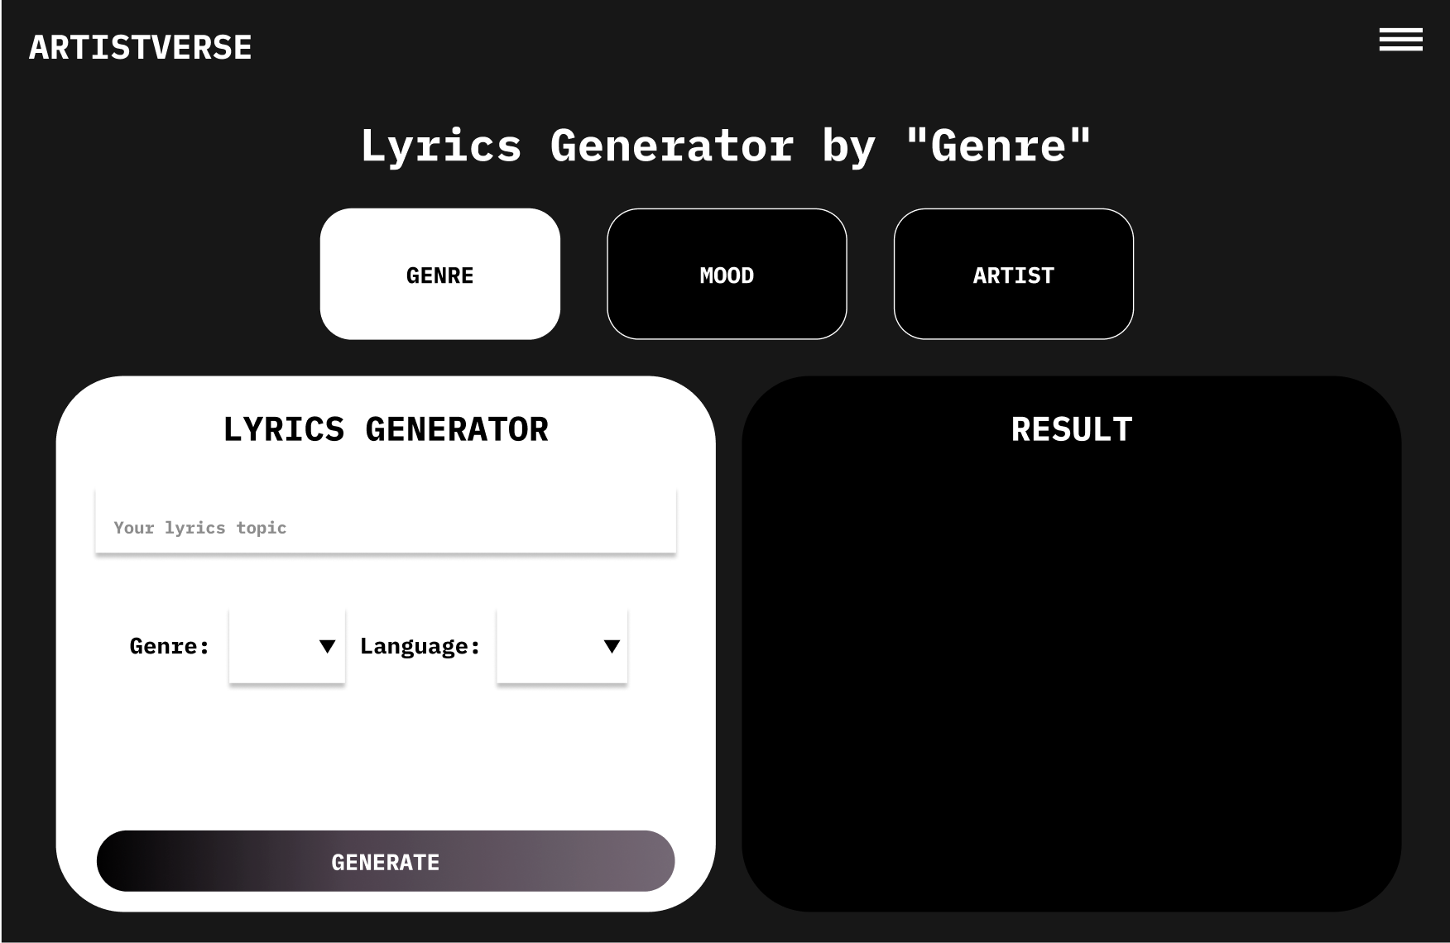

Test case:
No | Description | Input | Expected Result | result
1 | Verify Navbar  Toggler Icon  Display | Open the website  in a web browser. | The "navbar-toggler-icon" buttonis displayed in the top right bar ofevery page. | pass
2 | Verify  Dropdown  Navbar Display | Click on the  "navbar-toggler-icon" button. | A dropdown navbar is displayed. | pass
3 | Verify the  functionality ofthe  "navbar-toggler-icon" button. | Click the  "navbar-toggler-icon" button. | The system displays a drop-downmenu with options: "Homepage","Lyric Generator", "Mood  Camera", "Chord Progression",and "AI-Analysis". | pass
4 | Verify  navigation to  the Lyric  Generator page. | Select "Lyric  Generator" from  the drop-down  menu. | The system navigates to the  lyrics generator page. | pass
5 | Verify the  presence of the"Let's Generate"button. | Load the lyrics  generator page | The "Let's Generate" button is  displayed on the lyrics generatorpage. | pass
6 | Verify  functionality ofthe "Let's  Generate"  button. | Click the "Let's  Generate" button  on the lyrics  generator page. | The system displays options forcomposing lyrics: "Lyric  Generator by Genre", "Lyric  Generator by Mood", and "LyricGenerator by Style Artist". | pass

Document  Name | Artistverse-TestRecord  V.3.0 | Owner | NS , WS | Page | 36
Document  Type | Test Record | Release Date | 11/10/2024 | Print date | 11/10/2024

STC-02: View Artist Information
Description: This system verifies the process of generating lyrics based on a selectedgenre using the Lyric Generator feature.
Prepared Data: -
Test script:
1. Click the "Show Thai Artists" button.

Document  Name | Artistverse-TestRecord  V.3.0 | Owner | NS , WS | Page | 37
Document  Type | Test Record | Release Date | 11/10/2024 | Print date | 11/10/2024

2. Displays Thai artist information along with the "Show Non-Thai Artists" button.
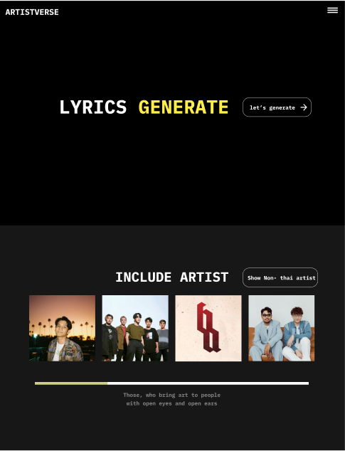
3. Displays a scroll bar to navigate through additional Thai artist information.4. Use the scroll bar to see additional Thai artist information.
5. Click the "Show Non-Thai Artists" button.
Document  Name | Artistverse-TestRecord  V.3.0 | Owner | NS , WS | Page | 38
Document  Type | Test Record | Release Date | 11/10/2024 | Print date | 11/10/2024

6. Displays the picture and name of the non-Thai artist along with the "Show Thai
Artists" button.

7. Displays a scroll bar to navigate through additional non-Thai artist information.8. Use the scroll bar to see additional non-Thai artist information.
Document  Name | Artistverse-TestRecord  V.3.0 | Owner | NS , WS | Page | 39
Document  Type | Test Record | Release Date | 11/10/2024 | Print date | 11/10/2024

Test case:
No | Description | Input | Expected Result | result
1 | Verify the  display of Thai  artist  information. | Click "Show Thai  Artists" button. | System displays Thai artist  information with a "Show  Non-Thai Artists" button. | pass
2 | Verify the  display of the  scroll bar for  Thai artists. | Scroll through the  Thai artist list. | System provides a scroll barto navigate through additionalThai artist information. | pass
3 | Verify the  display of  non-Thai artist  information. | Click "Show  Non-Thai Artists"  button. | System displays non-Thai  artist information with a  "Show Thai Artists" button. | pass
4 | Verify the  display of the  scroll bar for  non-Thai artists. | Scroll through thenon-Thai artist list. | System provides a scroll barto navigate through additionalnon-Thai artist information. | pass
5 | Verify the  switching  between Thai  and non-Thai  artist  information. | Click "Show Thai  Artists" button,  then click "Show  Non-Thai Artists"  button. | System correctly switches  between displaying Thai andnon-Thai artist information. | pass

Document  Name | Artistverse-TestRecord  V.3.0 | Owner | NS , WS | Page | 40
Document  Type | Test Record | Release Date | 11/10/2024 | Print date | 11/10/2024

STC-03: Compose Lyrics by Genre
Description: This system verifies the process of generating lyrics based on a selectedgenre using the Lyric Generator feature.
Prepared Data: -
Test script:
1. The system displays Lyric Generator Page Options.

2. Select "Lyric Generator by Genre"

Document  Name | Artistverse-TestRecord  V.3.0 | Owner | NS , WS | Page | 41
Document  Type | Test Record | Release Date | 11/10/2024 | Print date | 11/10/2024

3. Fill in the required information in the form.
4. Click on the "GENERATE" button to start generating lyrics.
Test case:
No | Description | Input | Expected Result | result
1 | Provide  information in  the form. | - Lyric topic: "Mylove"  - Genre: Select  "pop" from the  dropdown  - Language: Select"English" from thedropdown | The generated lyrics are  displayed on the page basedon the provided inputs. | pass
2 | Verify Error  Handling  (Missing Fields- All Empty) | - Lyric topic: ""  - Genre: ""  - Language: "" | The system displays an errormessage indicating the  missing fields  ("Please input a lyric topic.","Please select genre.", "Pleaseselect a language."). | pass
3 | Verify Error  Handling  (Missing Genreand Language) | - Lyric topic: "Mylove"  - Genre: ""  - Language: "" | The system displays an errormessage indicating the  missing fields  ("Please select genre.",  "Please select a language."). | pass
4 | Verify Error  Handling  (Missing Genre) | - Lyric topic: "Mylove"  - Genre: ""  - Language: Select"English" from thedropdown | The system displays an errormessage indicating the  missing fields  ("Please select genre.”). | pass
4 | Verify Error  Handling  (Missing  Language) | - Lyric topic: "Mylove"  - Genre: Select  "pop" from the  dropdown  - Language: "" | The system displays an errormessage indicating the  missing fields  ("Please select a language."). | pass
5 | Verify Error  Handling  (Missing Lyric | - Lyric topic: ""  - Genre: Select  "pop" from the | The system displays an errormessage indicating the  missing fields | pass

Document  Name | Artistverse-TestRecord  V.3.0 | Owner | NS , WS | Page | 42
Document  Type | Test Record | Release Date | 11/10/2024 | Print date | 11/10/2024

 | topic) | dropdown  - Language: Select"English" from thedropdown | ("Please input a lyric topic.").
6 | Verify Error  Handling (No  Internet  Connection) | Disconnect the  internet and click  the "generate"  button. | The system displays an errormessage  "Unable to compose lyrics." | pass

Document  Name | Artistverse-TestRecord  V.3.0 | Owner | NS , WS | Page | 43
Document  Type | Test Record | Release Date | 11/10/2024 | Print date | 11/10/2024

STC-04: Compose Lyrics by Mood
Description: This system verifies the process of generating lyrics based on a selectedmood using the Lyric Generator feature.
Prepared Data:
Test script:
1. The system displays Lyric Generator Page Options.

2. Select "Lyric Generator by Mood"
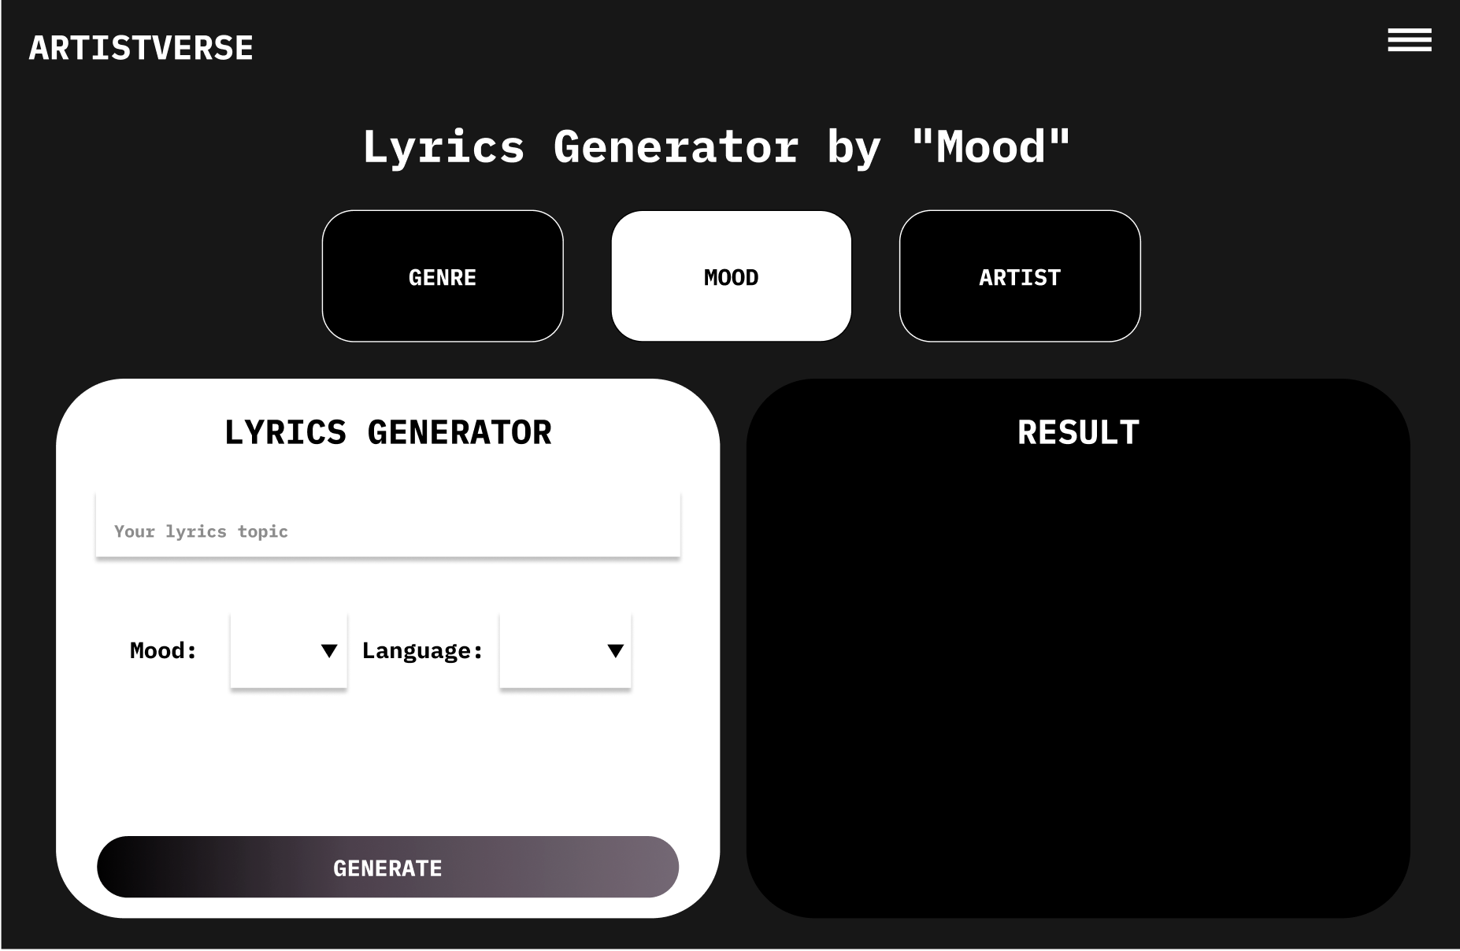
Document  Name | Artistverse-TestRecord  V.3.0 | Owner | NS , WS | Page | 44
Document  Type | Test Record | Release Date | 11/10/2024 | Print date | 11/10/2024

3. Fill in the required information in the form.
4. Click on the "GENERATE" button to start generating lyrics.
Test case:
No | Description | Input | Expected Result | Result
1 | Provide  information in  the form. | - Lyric topic: "Mylove"  - Mood: Select  "Romantic" from  the dropdown  - Language: Select"English" from thedropdown | The generated lyrics are  displayed on the page based onthe provided inputs. | pass
2 | Verify Error  Handling  (Missing Fields- All Empty) | - Lyric topic: ""  - Mood: ""  - Language: "" | The system displays an error  message indicating the missingfields  ("Please input a lyric topic.",  "Please select mood.", "Pleaseselect a language."). | pass
3 | Verify Error  Handling  (Missing mood  and Language) | - Lyric topic: "Mylove"  - Mood: ""  - Language: "" | The system displays an error  message indicating the missingfields  ("Please select mood.", "Pleaseselect a language."). | pass
4 | Verify Error  Handling  (Missing Mood) | - Lyric topic: "Mylove"  - Mood: ""  - Language: Select"English" from thedropdown | The system displays an error  message indicating the missingfields  ("Please select mood.”). | pass
4 | Verify Error  Handling  (Missing  Language) | - Lyric topic: "Mylove"  - Mood: Select  "Romantic" from  the dropdown  - Language: "" | The system displays an error  message indicating the missingfields  ("Please select a language."). | pass
5 | Verify Error  Handling  (Missing Lyric | - Lyric topic: ""  - Mood: Select  "Romantic" from | The system displays an error  message indicating the missingfields | pass

Document  Name | Artistverse-TestRecord  V.3.0 | Owner | NS , WS | Page | 45
Document  Type | Test Record | Release Date | 11/10/2024 | Print date | 11/10/2024

 | topic) | the dropdown  - Language: Select"English" from thedropdown | ("Please input a lyric topic.").
6 | Verify Error  Handling (No  Internet  Connection) | Disconnect the  internet and click  the "generate"  button. | The system displays an error  message  "Unable to compose lyrics." | pass

Document  Name | Artistverse-TestRecord  V.3.0 | Owner | NS , WS | Page | 46
Document  Type | Test Record | Release Date | 11/10/2024 | Print date | 11/10/2024

STC-05: Compose Lyrics by Style Artist
Description: This system verifies the process of generating lyrics based on a selectedartist using the Lyric Generator feature.
Prepared Data:
Test script:
1. The system displays Lyric Generator Page Options.

2. Select "Lyric Generator by Style Artist"
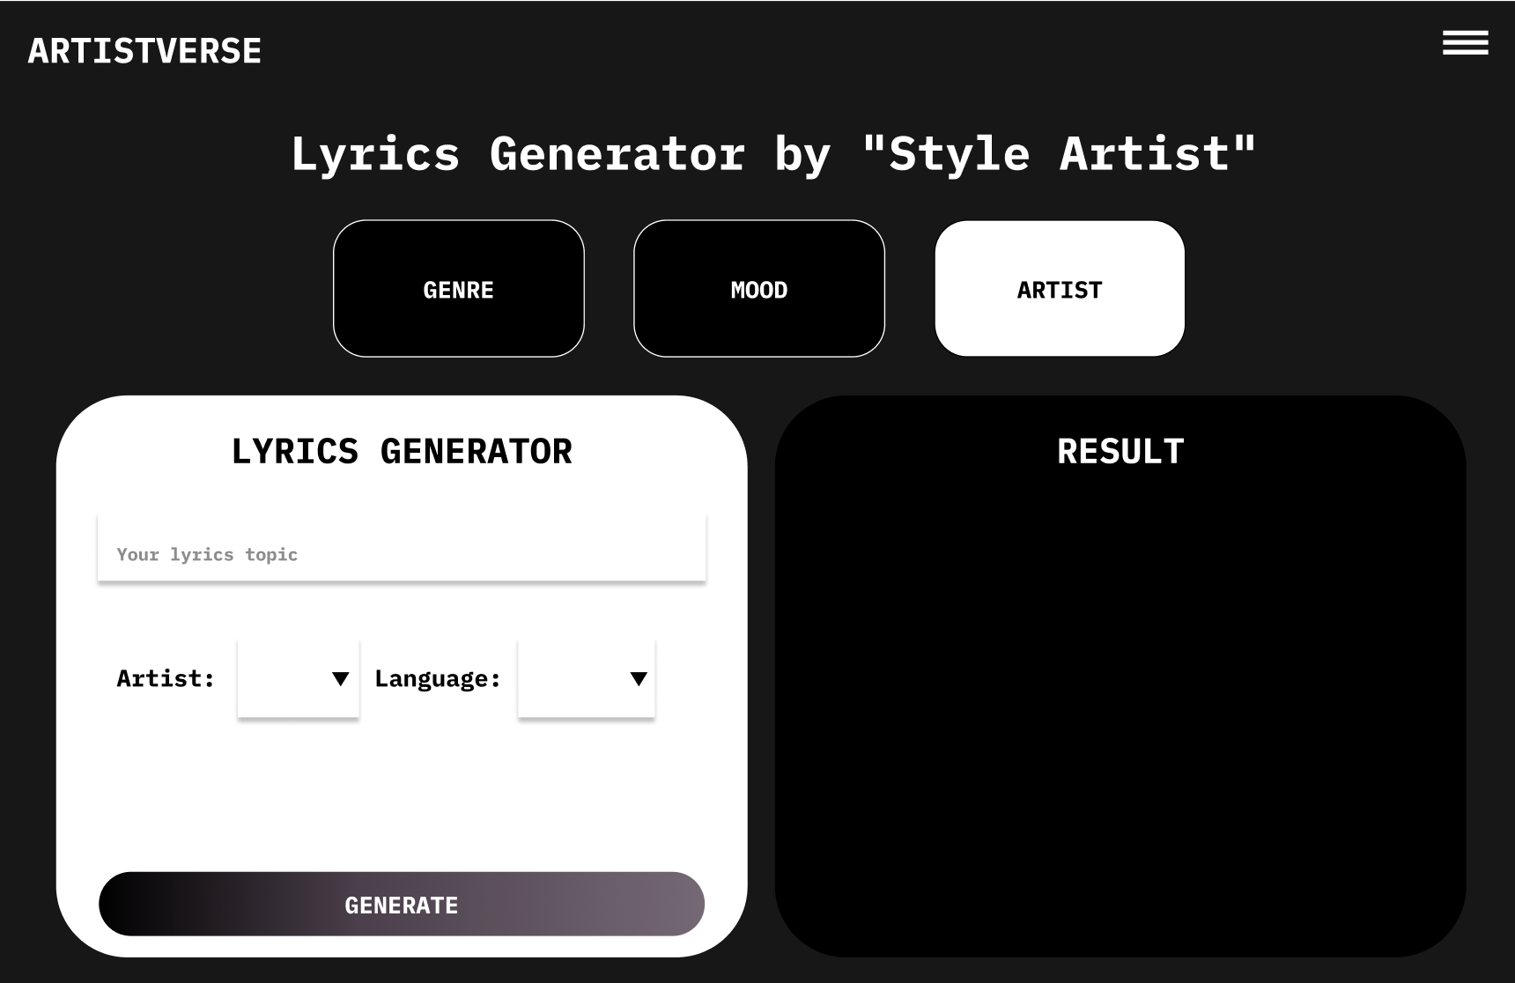
Document  Name | Artistverse-TestRecord  V.3.0 | Owner | NS , WS | Page | 47
Document  Type | Test Record | Release Date | 11/10/2024 | Print date | 11/10/2024

3. Fill in the required information in the form.
4. Click on the "GENERATE" button to start generating lyrics
Test case:
No | Description | Input | Expected Result | result
1 | Provide  information in  the form. | - Lyric topic: "Mylove"  - Artist: Select  "Taylor Swift"  from the dropdown- Language: Select"English" from thedropdown | The generated lyrics are  displayed on the page  based on the provided  inputs. | pass
2 | Verify Error  Handling  (Missing Fields- All Empty) | - Lyric topic: ""  - Artist: ""  - Language: "" | The system displays an  error message indicating  the missing fields  ("Please input a lyric  topic.", "Please select  artist.", "Please select a  language."). | pass
3 | Verify Error  Handling  (Missing artist  and Language) | - Lyric topic: "Mylove"  - Artist: ""  - Language: "" | The system displays an  error message indicating  the missing fields  ("Please select artist.",  "Please select a  language."). | pass
4 | Verify Error  Handling  (Missing Artist) | - Lyric topic: "Mylove"  - Artist: ""  - Language: Select"English" from thedropdown | The system displays an  error message indicating  the missing fields  ("Please select artist.”). | pass
4 | Verify Error  Handling  (Missing  Language) | - Lyric topic: "Mylove"  - Mood: Select  "Romantic" from  the dropdown  - Language: "" | The system displays an  error message indicating  the missing fields  ("Please select a  language."). | pass
5 | Verify Error | - Lyric topic: "" | The system displays an | pass

Document  Name | Artistverse-TestRecord  V.3.0 | Owner | NS , WS | Page | 48
Document  Type | Test Record | Release Date | 11/10/2024 | Print date | 11/10/2024

 | Handling  (Missing Lyric  topic) | - Artist: Select  "Taylor Swift"  from the dropdown- Language: Select"English" from thedropdown | error message indicating  the missing fields  ("Please input a lyric  topic.").
6 | Verify Error  Handling (No  Internet  Connection) | Disconnect the  internet and click  the "generate"  button. | The system displays an  error message  "Unable to compose  lyrics." | pass

Document  Name | Artistverse-TestRecord  V.3.0 | Owner | NS , WS | Page | 49
Document  Type | Test Record | Release Date | 11/10/2024 | Print date | 11/10/2024

STC-06: Save lyrics
Description: This system verifies the functionality of saving lyrics to the songwriter'slocal computer.
Prepared Data:
Test script:
1.The system displays the generated lyrics to the songwriter.
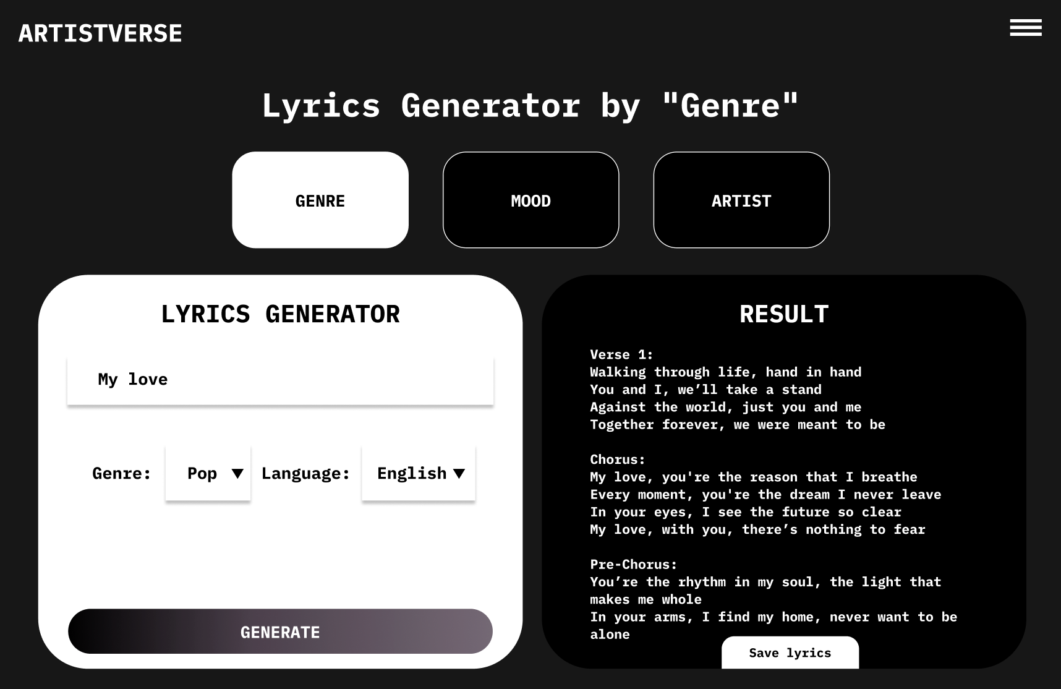
2. Click on the "Save" button
Test case:
No | Description | Input | Expected Result | Result
1 | Click the  "Save" button | Click on the "Save"button | The system starts the  process of saving the  lyrics to the composer's  computer in a.txt file  format. | pass
2 | Handle no  internet  connection | Disconnect the  internet and  attempt to save | The system displays an  error message "Unable tosave lyrics". | pass

Document  Name | Artistverse-TestRecord  V.3.0 | Owner | NS , WS | Page | 50
Document  Type | Test Record | Release Date | 11/10/2024 | Print date | 11/10/2024

STC-07: Songwriter can capture facial expressions to detect mood and receiverecommended song
Description: The system testing for songwriter can capture facial expressions todetect mood and receive a recommended song.
Prepared Data:
●  ● | The songwriter has granted permission for camera access.  ●  Test data in Appendix A
Test script:
1. Click "Camera Mood" page.
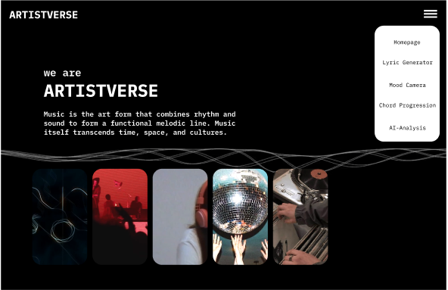
Document  Name | Artistverse-TestRecord  V.3.0 | Owner | NS , WS | Page | 51
Document  Type | Test Record | Release Date | 11/10/2024 | Print date | 11/10/2024

2. System redirects to the Camera Mood page.
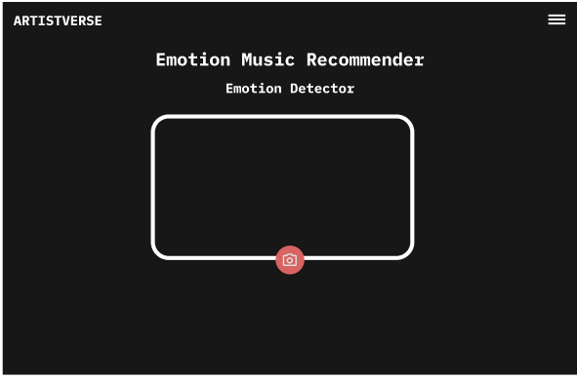
3. Click the "Capture" button.
4. System receives the facial expression of the songwriter.
5. The system analyzes the facial expression to determine the songwriter's mood.6. The system displays the detected mood
(Happy,Sad,Neutral,Angry,Fearful,Surprised).
7. The system requests a song from the specific mood playlist on Spotify using
Spotify API.
8. The system displays the recommended songs with a "Listen on Spotify"
button.
Test case:
No | Description | Input | Expected Result | Result
1 | Songwriter clicks  "Capture" button | Click "Capture"button | System displays the  camera view and  provides capture button | pass
2 | System receives facial  expression | Facial  expression  image | System analyzes facialexpression to determinemood | pass
3 | Unable to detect mood | Unclear facial  expression  image | System displays "Moodcould not be detected,Try again" | pass

Document  Name | Artistverse-TestRecord  V.3.0 | Owner | NS , WS | Page | 52
Document  Type | Test Record | Release Date | 11/10/2024 | Print date | 11/10/2024

4 | Detects mood and  recommends song | Clear facial  expression  image | System displays  detected mood and  recommended songs | pass
5 | Songwriter clicks "reset"button to capture again | Click "reset"  button | System clears all inputand returns to camera  view | pass
6 | Songwriter denies  camera access | Deny camera  access | System ends with  failure message | pass

Document  Name | Artistverse-TestRecord  V.3.0 | Owner | NS , WS | Page | 53
Document  Type | Test Record | Release Date | 11/10/2024 | Print date | 11/10/2024

STC-08: Songwriter can select song from recommended playlist to listen on Spotify
Description: The system testing for songwriter can select a song from therecommended playlist to listen on the Spotify platform.
Prepared Data:
●  ● | Songwriter has completely detected the mood and recommended the song.  ●  Test data Appendix A
Test script:
1. Songwriter selects a song by clicking the "Listen on Spotify" button in the
recommended songs on the playlist.
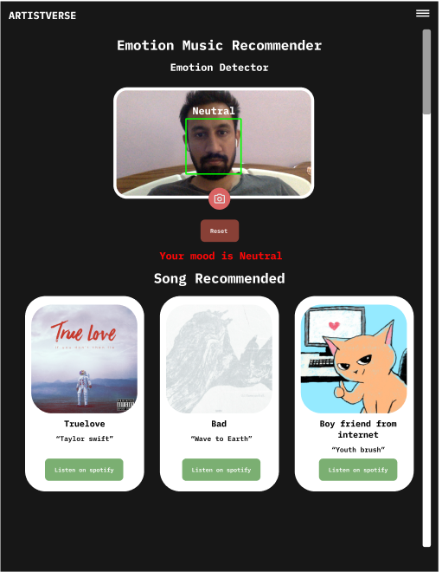
2. The system retrieves the Spotify link of the selected song from the database.3. The system redirects the songwriter to the Spotify interface using the Spotify
link.
Document  Name | Artistverse-TestRecord  V.3.0 | Owner | NS , WS | Page | 54
Document  Type | Test Record | Release Date | 11/10/2024 | Print date | 11/10/2024

Test case:
No | Description | Input | Expected Result | Result
1 | Songwriter selects a  recommended song | Click "Listen onSpotify" button | System  redirects  songwriter to  Spotify  interface with  the song | pass
2 | System retrieves  Spotify link from  database | Selected song | System  successfully  redirects to  Spotify  interface | pass
3 | Songwriter has internetconnection | Internet access | System displayserror message  about internet  connectivity | pass
4 | Songwriter does not  have internet  connection | No internet  access | System displayserror message  about internet  connectivity | pass

Document  Name | Artistverse-TestRecord  V.3.0 | Owner | NS , WS | Page | 55
Document  Type | Test Record | Release Date | 11/10/2024 | Print date | 11/10/2024

4.2 Progress II
STC-09: Access "Chord Progression" Page
Description: This test case verifies that the songwriter can access the "ChordProgression" page from the navigation menu.
Prepared Data: None
Test script:
1. Open the Artistverse website in a web browser.

2. Click the "navbar-toggler-icon" button.

Document  Name | Artistverse-TestRecord  V.3.0 | Owner | NS , WS | Page | 56
Document  Type | Test Record | Release Date | 11/10/2024 | Print date | 11/10/2024

3. The system displays a drop-down menu with options: "Homepage", "Lyric
Generator", "Mood Camera", "Chord Progression", and "AI-Analysis".

4. Select "Chord progression" from the dropdown menu.
5. The system displays the Chord Progression page.
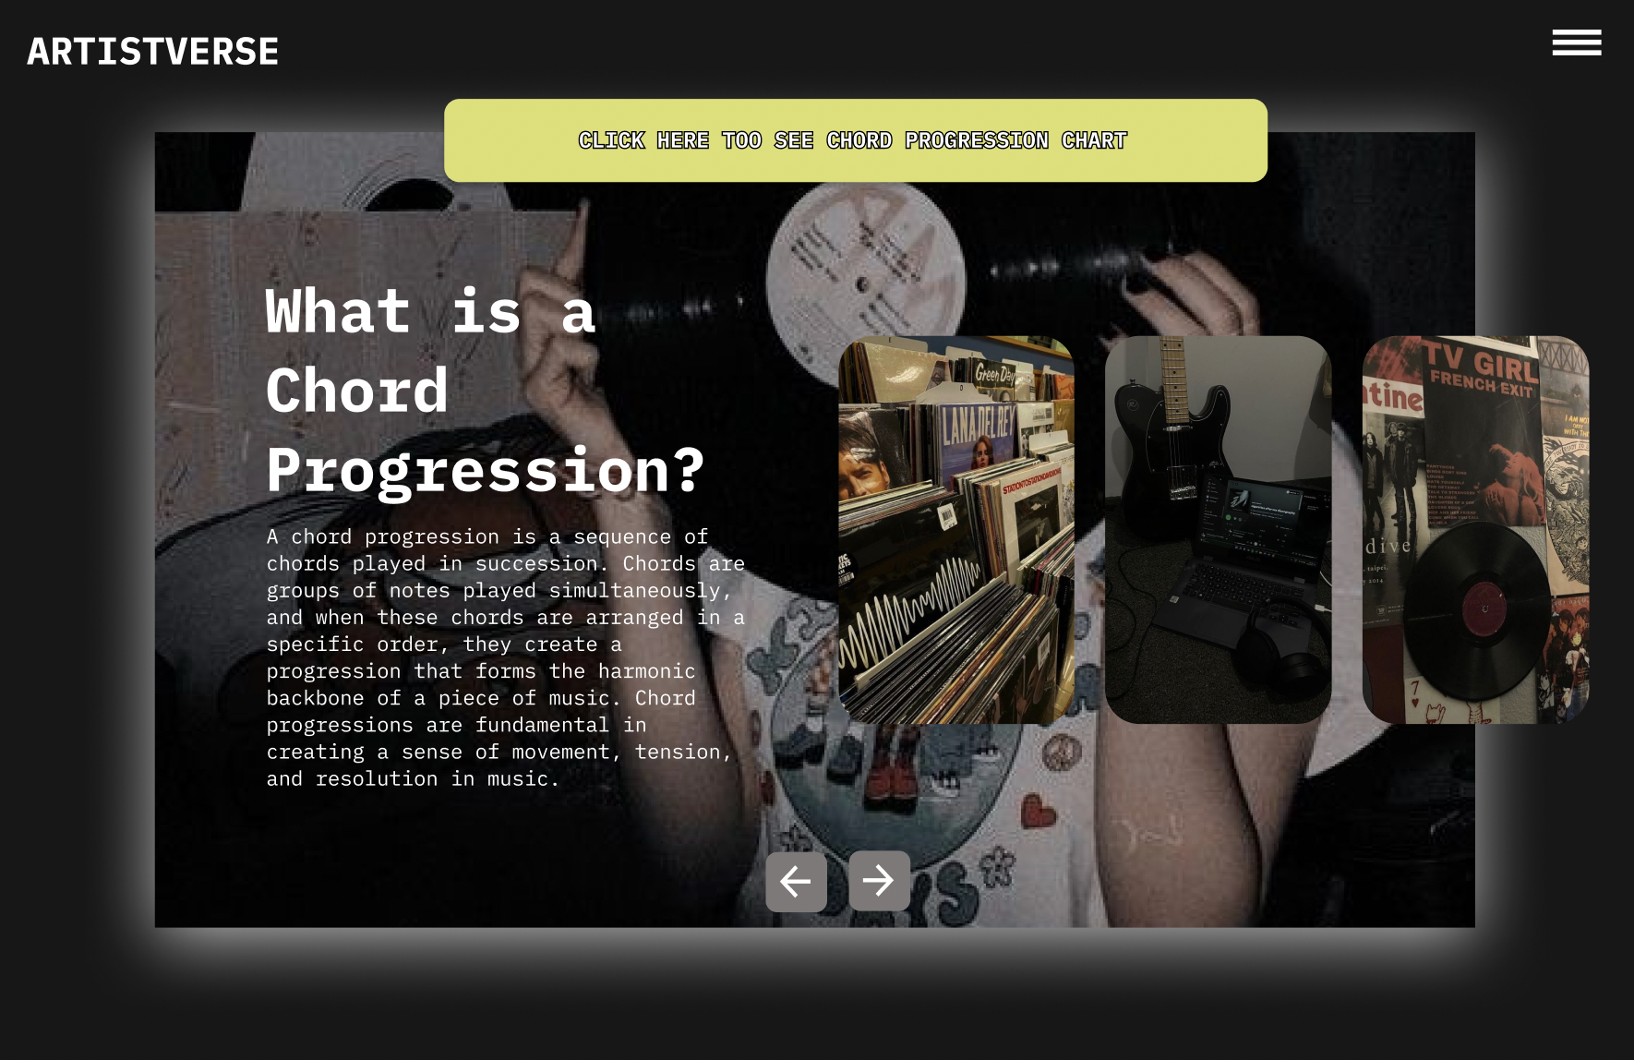
Document  Name | Artistverse-TestRecord  V.3.0 | Owner | NS , WS | Page | 57
Document  Type | Test Record | Release Date | 11/10/2024 | Print date | 11/10/2024

Test case:
No | Description | Input | Expected Result | Result
1 | Verify Navbar  Toggler Icon Display | Open the websitein a web browser. | The "navbar-toggler-icon"  button is displayed in the topright bar of every page. | pass
2 | Verify Dropdown  Navbar Display | Click on the  "navbar-toggler-icon" button. | A dropdown navbar is  displayed. | pass
3 | Verify the  functionality of the  "navbar-toggler-icon"button. | Click the  "navbar-toggler-icon" button. | The system displays a  drop-down menu with  options: "Homepage", "LyricGenerator", "Mood Camera","Chord Progression", and  "AI-Analysis". | pass
4 | Verify navigation to  the Chord  Progression page. | Select "Chord  Progression"  from the  drop-down menu. | The system navigates to the  Chord Progression page. | pass

Document  Name | Artistverse-TestRecord  V.3.0 | Owner | NS , WS | Page | 58
Document  Type | Test Record | Release Date | 11/10/2024 | Print date | 11/10/2024

STC-10: Navigate Between Chord Progressions
Description: This test case verifies that the songwriter can navigate between differentchord progressions using the "Next" and "Back" buttons.
Prepared Data: None
Test script:
1. The system displays the main page.

2. Click the "Next" button to view the next chord progression.
3. The system displays the next chord progression.
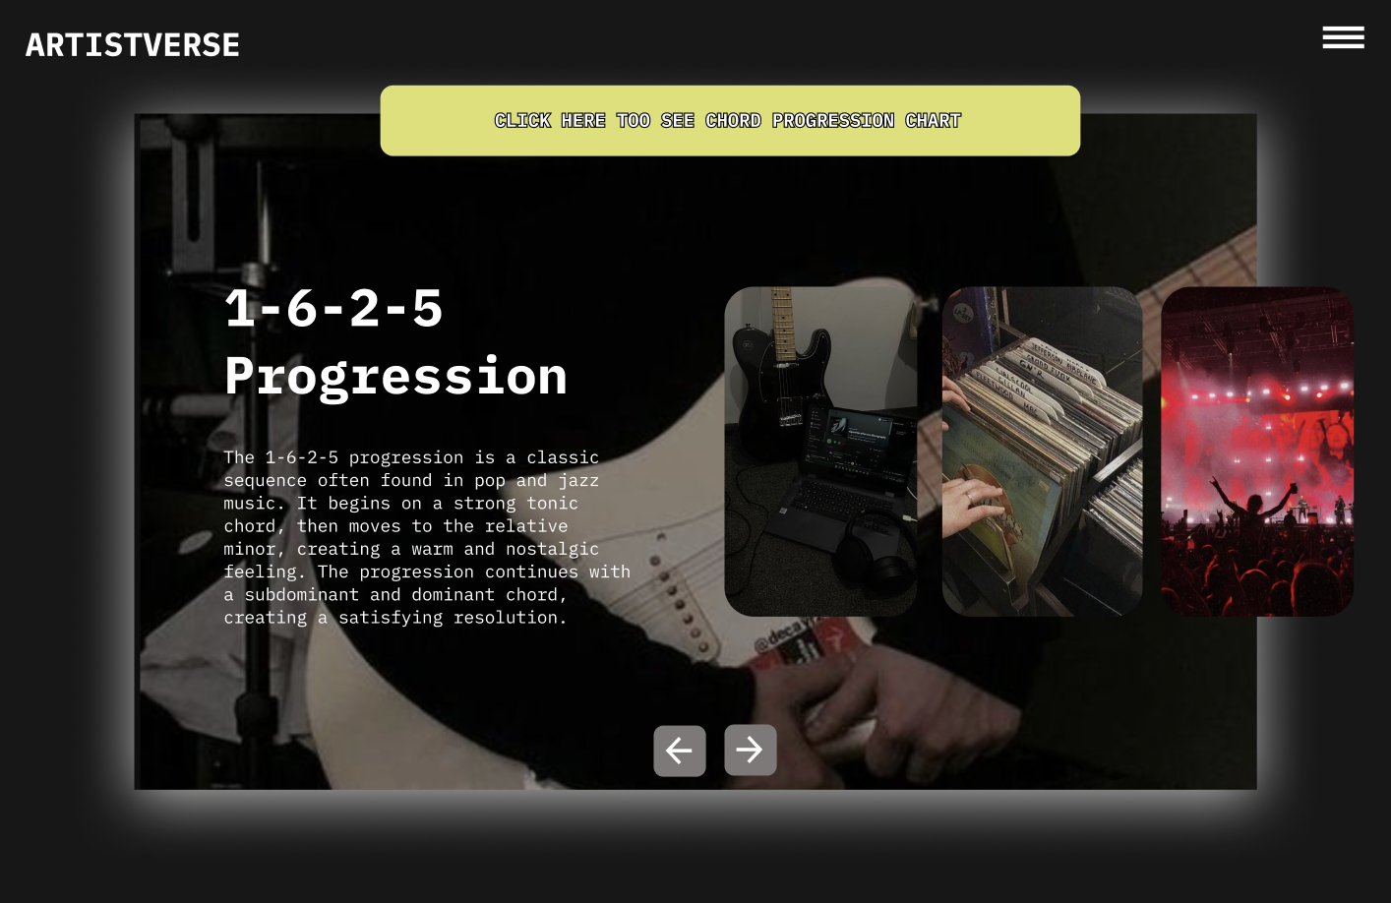
Document  Name | Artistverse-TestRecord  V.3.0 | Owner | NS , WS | Page | 59
Document  Type | Test Record | Release Date | 11/10/2024 | Print date | 11/10/2024

4. Click the "Back" button to return to the previous chord progression or the
main page.
5. The system displays the previous chord progression or returns to the main
page.

Test case:
No | Description | Input | Expected Result | Result
1 | Verify that the systemdisplays the main  "Chord Progression"page. | Access the  "Chord  Progression"  page. | The main "Chord Progression"page with introductory  information is displayed. | pass
2 | Verify that clicking  the "Next" button  displays the next  chord progression. | Click the "Next"button on the  chord progressionpage. | The system displays the nextchord progression. | pass
3 | Verify that the systemdisplays detailed  information about thenext chord  progression. | - | The system displays detailedinformation about the next  chord progression. | pass
4 | Verify that clicking  the "Back" button  returns to the  previous chord  progression or the  main page. | Click the "Back"button on the  chord progressionpage. | The system displays the  previous chord progression orreturns to the main page. | pass

Document  Name | Artistverse-TestRecord  V.3.0 | Owner | NS , WS | Page | 60
Document  Type | Test Record | Release Date | 11/10/2024 | Print date | 11/10/2024

5 | Verify that the systemdisplays the previouschord progression orreturns to the main  page. | - | The system displays the  previous chord progression orthe main "Chord Progression"page. | pass

Document  Name | Artistverse-TestRecord  V.3.0 | Owner | NS , WS | Page | 61
Document  Type | Test Record | Release Date | 11/10/2024 | Print date | 11/10/2024

STC-11: View Chord Progression Chart
Description: This test case verifies that the songwriter can view the chordprogression chart after accessing the "Chord Progression" page.
Prepared Data: None
Test script:
1. The system displays the "CLICK HERE TO SEE CHORD PROGRESSION
CHART" button.

2. Click the "CLICK HERE TO SEE CHORD PROGRESSION CHART"
button.
3. The system displays a chart showing various chord progressions and keys.
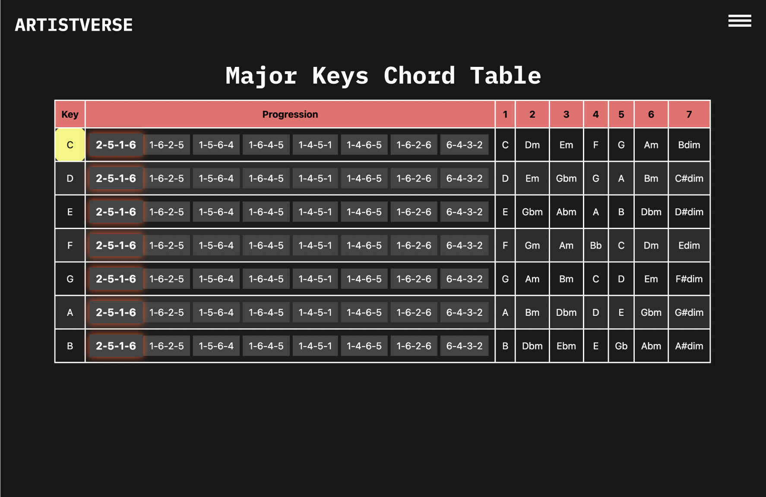
Document  Name | Artistverse-TestRecord  V.3.0 | Owner | NS , WS | Page | 62
Document  Type | Test Record | Release Date | 11/10/2024 | Print date | 11/10/2024

Test case:
No | Description | Input | Expected Result | Result
1 | Verify the system  displays the "CLICKHERE TO SEE  CHORD  PROGRESSION  CHART" button. | Access the  "Chord  Progression"  page. | The "CLICK HERE TO  SEE CHORD  PROGRESSION CHART"button is visible. | pass
2 | Click the "CLICK  HERE TO SEE  CHORD  PROGRESSION  CHART" button. | Click the  "CLICK HERE  TO SEE CHORDPROGRESSIONCHART" button. | The system displays a chartshowing various chord  progressions and keys. | pass

Document  Name | Artistverse-TestRecord  V.3.0 | Owner | NS , WS | Page | 63
Document  Type | Test Record | Release Date | 11/10/2024 | Print date | 11/10/2024

STC-12: Interact with Chord Progression Chart
Description: This test case verifies that the songwriter can select and highlight achord progression from the chart and view corresponding guitar chord diagrams.
Prepared Data: None
Test script:
1. Select a chord progression from the table (2-5-1-6, 1-6-2-5, 1-5-6-4, 1-6-4-5,
1-4-5-1,1-4-6-5, 1-6-2-6, 6-4-3-2).
2. The system highlights the selected progression and key in yellow.
3. The system displays a series of guitar chord diagrams corresponding to the
selected progression below the chart.
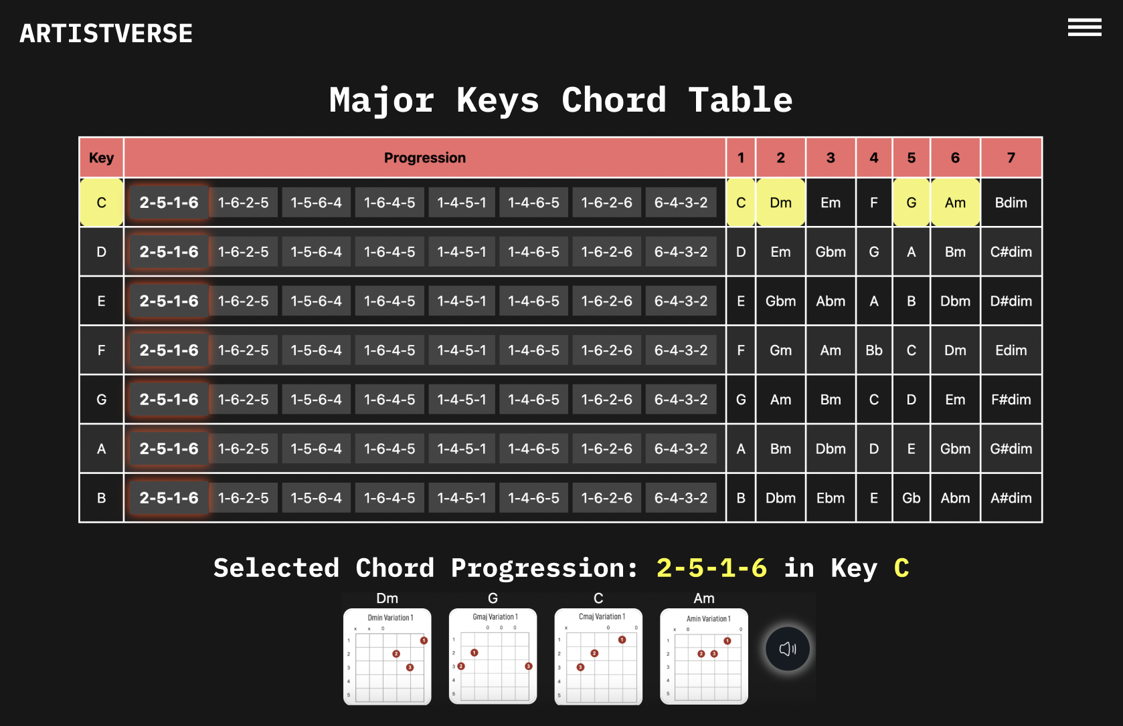
Document  Name | Artistverse-TestRecord  V.3.0 | Owner | NS , WS | Page | 64
Document  Type | Test Record | Release Date | 11/10/2024 | Print date | 11/10/2024

Test case:
No | Description | Input | Expected Result | Result
1 | Select a chord  progression from thetable. | Select a  progression  (2-5-1-6 in C  major). | The selected progressionand key are highlighted inyellow. | pass
2 | Verify the system  displays guitar chorddiagrams. | Select a  progression. | The system displays  guitar chord diagrams  corresponding to the  selected progression. | pass

Document  Name | Artistverse-TestRecord  V.3.0 | Owner | NS , WS | Page | 65
Document  Type | Test Record | Release Date | 11/10/2024 | Print date | 11/10/2024

STC-13: Listen to Piano Audio Playback
Description: This test case verifies that the songwriter can listen to the piano audioplayback of the selected chord progression.
Prepared Data: None
Test script:
1. Click the "sound" button to listen to the piano audio playback of the selected
chord progression.

2. The system highlights the chord in the progression with an orange color as it is
played.
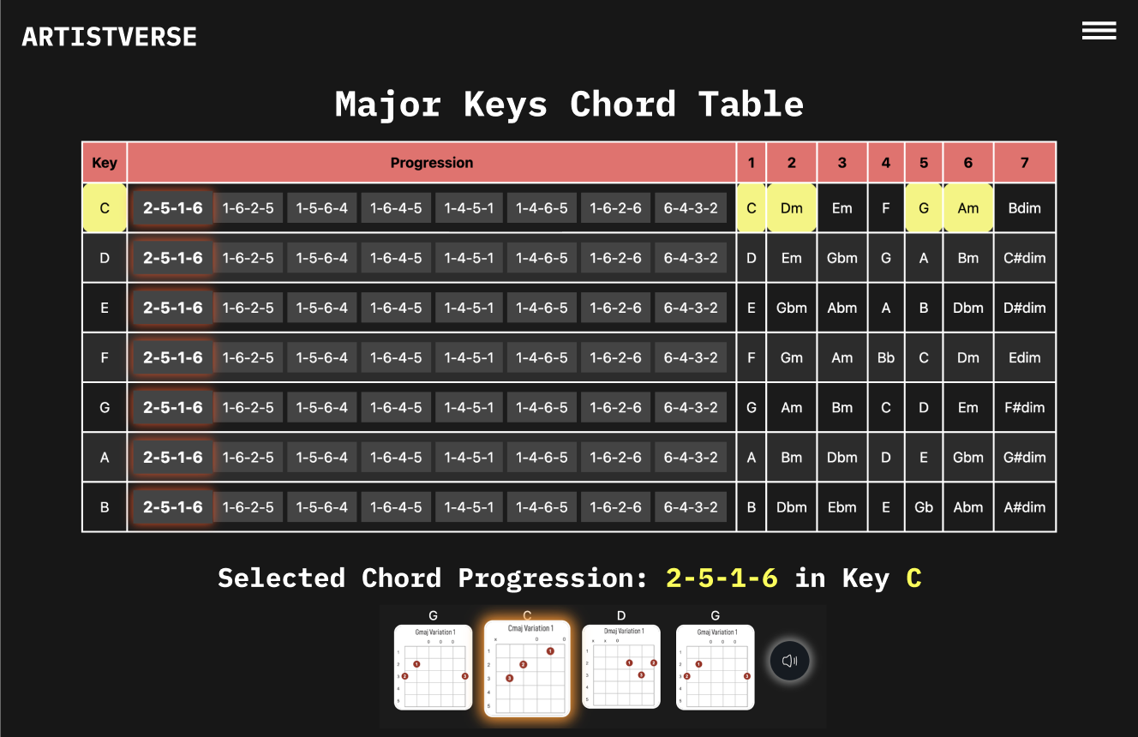
Document  Name | Artistverse-TestRecord  V.3.0 | Owner | NS , WS | Page | 66
Document  Type | Test Record | Release Date | 11/10/2024 | Print date | 11/10/2024

3. As the audio playback progresses, the system moves the highlight to the next
chord.
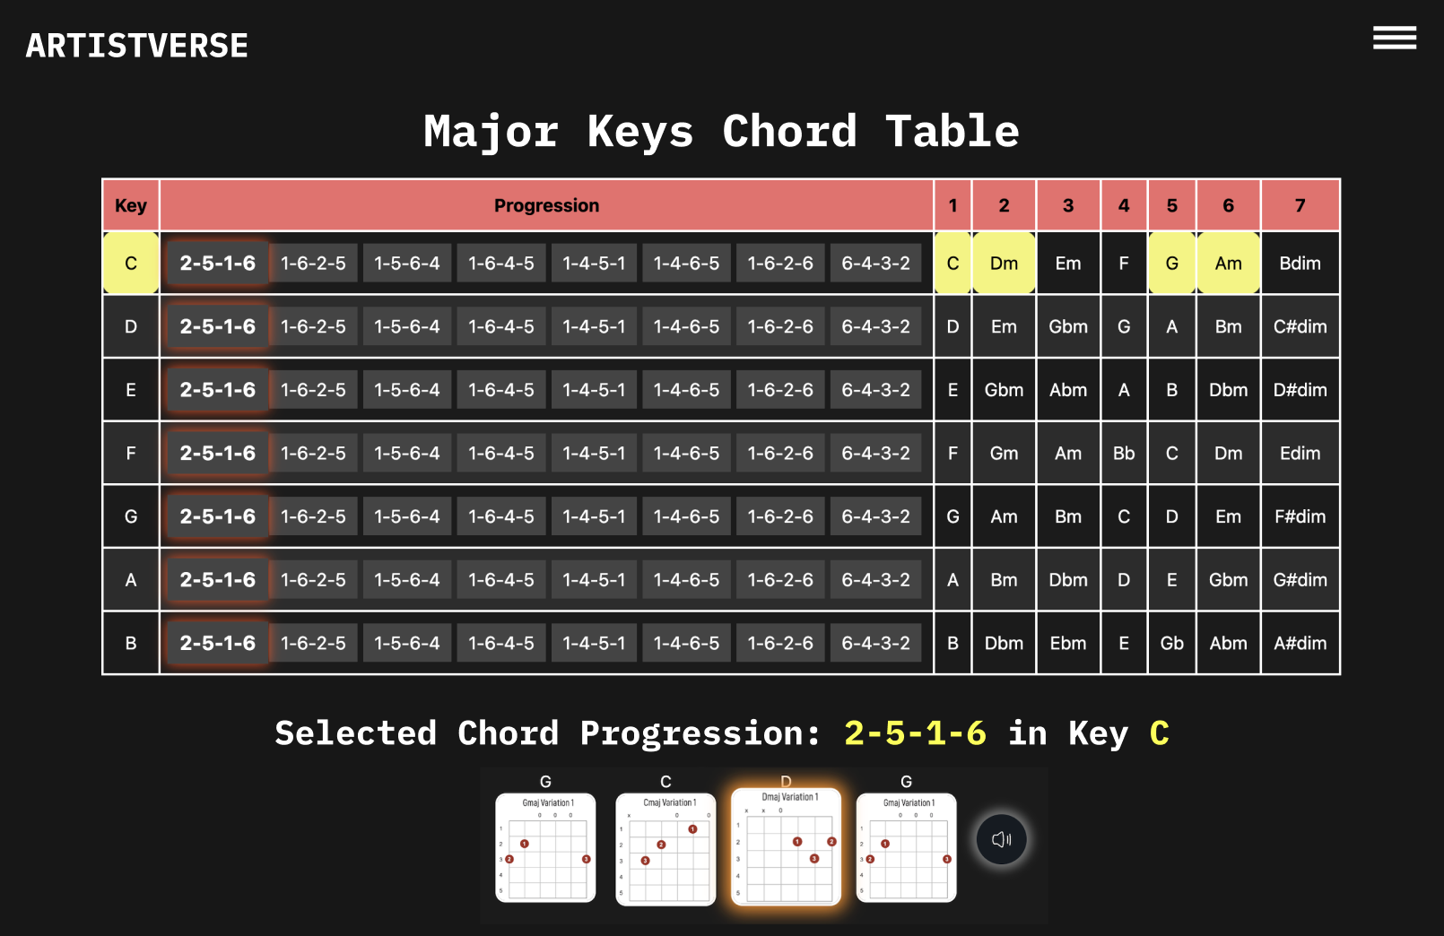
4. The system stops highlighting chords when the audio playback finishes.
Test case:
No | Description | Input | Expected Result | Result
1 | Verify that clicking  the "sound" button  starts playing the  chord progression  audio. | Click the "sound"button. | The audio playback of theselected chord  progression starts. | pass
2 | Verify that the systemhighlights the chord  currently being  played during the  audio playback. | Observe the  highlights duringplayback. | The system highlights thechord in the progressionwith an orange color as itis played. | pass
3 | Verify that the systemhighlights the next  chord as the playbackprogresses. | Observe the  progression  during playback. | As the audio playback  progresses, the system  moves the highlight to thenext chord. | pass
4 | Verify that the systemstops highlighting thechords when the  playback finishes. | Wait for the  playback to  finish. | The system stops  highlighting chords whenthe audio playback  finishes. | pass

Document  Name | Artistverse-TestRecord  V.3.0 | Owner | NS , WS | Page | 67
Document  Type | Test Record | Release Date | 11/10/2024 | Print date | 11/10/2024

STC-14: Access AI Analysis Page
Description: This system verifies that the navbar and navigate to Ai-Analysis pagecorrectly
Prepared Data: None
Test script:
1. Open the Artistverse website in a web browser.

2. Click the "navbar-toggler-icon" button.

Document  Name | Artistverse-TestRecord  V.3.0 | Owner | NS , WS | Page | 68
Document  Type | Test Record | Release Date | 11/10/2024 | Print date | 11/10/2024

3. The system displays a drop-down menu with options: "Homepage", "Lyric
Generator", "Mood Camera", "Chord Progression", and "AI-Analysis".

4. Select "AI-Analysis" from the dropdown menu.

Document  Name | Artistverse-TestRecord  V.3.0 | Owner | NS , WS | Page | 69
Document  Type | Test Record | Release Date | 11/10/2024 | Print date | 11/10/2024

5. The system display AI-Analysis page
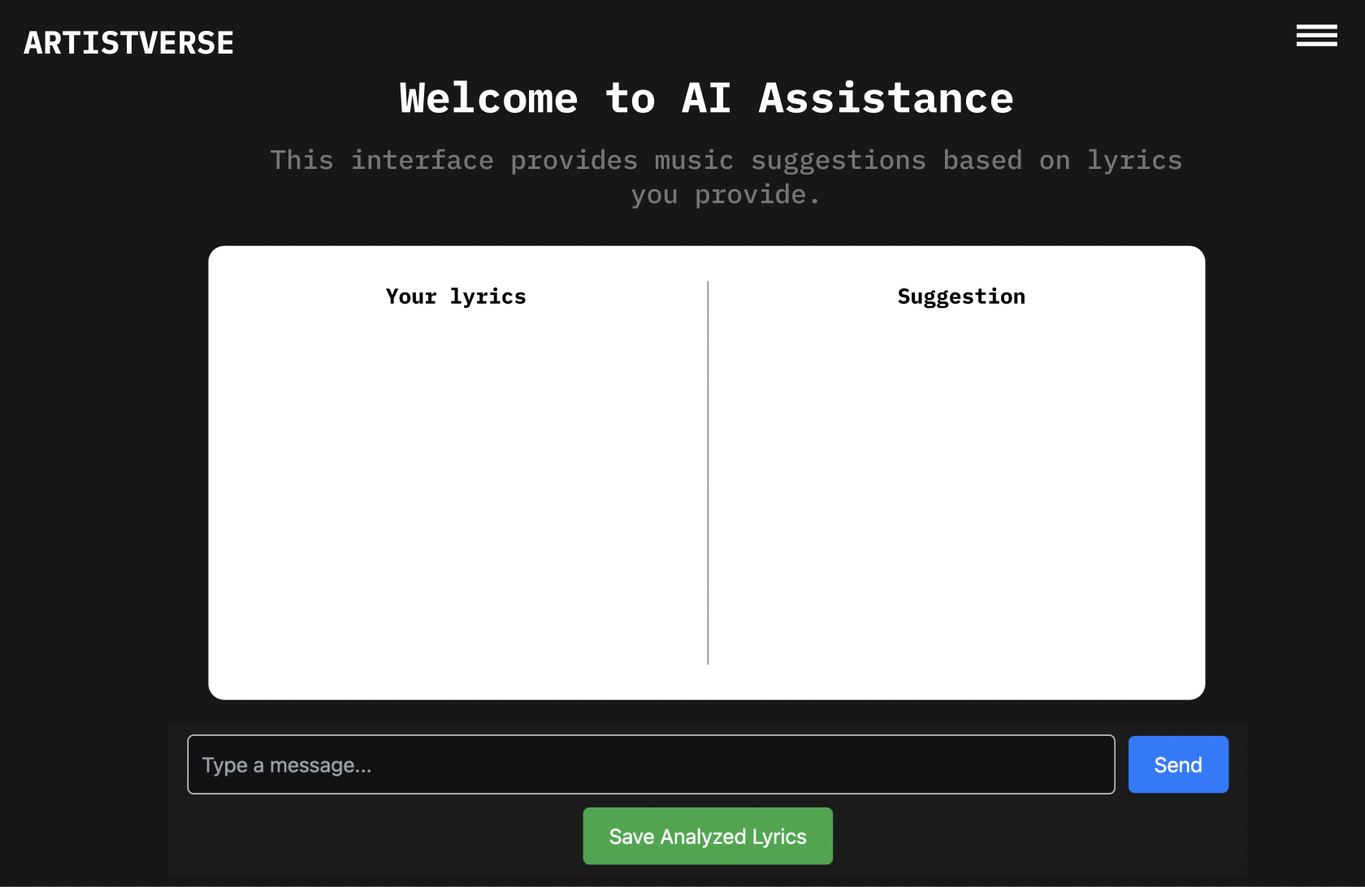
Test case:
No | Description | Input | Expected Result | Result
1 | Verify Navbar  Toggler Icon  Display | Open the  website in a  web browser. | The "navbar-toggler-icon"button is displayed in the  top right bar of every page. | pass
2 | Verify Dropdown  Navbar Display | Click on the  "navbar-toggler-icon" button. | A dropdown navbar is  displayed. | pass
3 | Verify the  functionality of the"navbar-toggler-icon" button. | Click the  "navbar-toggler-icon" button. | The system displays a  drop-down menu with  options: "Homepage",  "Lyric Generator", "MoodCamera", "Chord  Progression", and  "AI-Analysis". | pass
4 | Verify navigation tothe AI-Analysis  page. | Select  "AI-Analysis"  from the  drop-down  menu. | The system navigates to theAi-Analysis page. | pass

Document  Name | Artistverse-TestRecord  V.3.0 | Owner | NS , WS | Page | 70
Document  Type | Test Record | Release Date | 11/10/2024 | Print date | 11/10/2024

STC-15: Input Lyrics and Analyze
Description: This test verifies that the songwriter can input lyrics, analyze them, anddisplay the results correctly.
Prepared Data: Sample lyrics for input.
Test script:
1. Input lyrics into the text field.
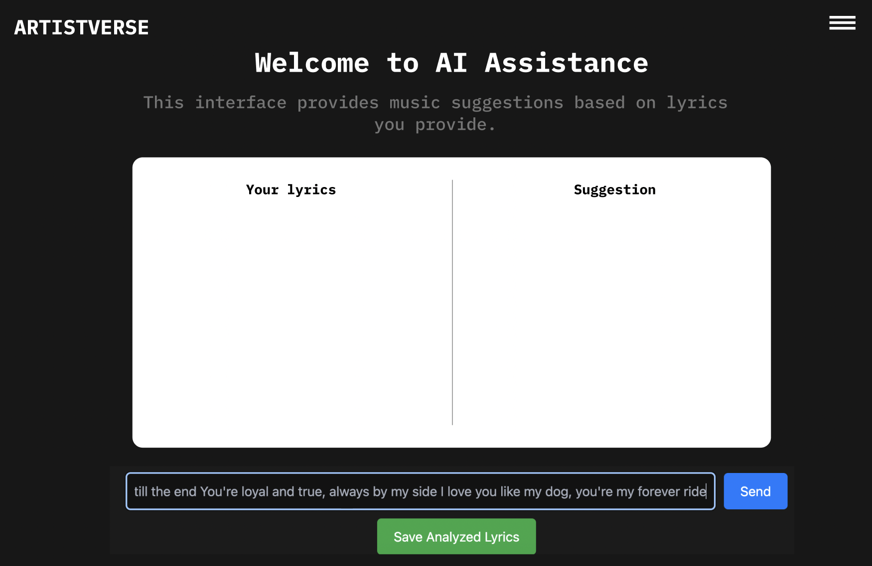
2. Click "Send" to analyze the lyrics.
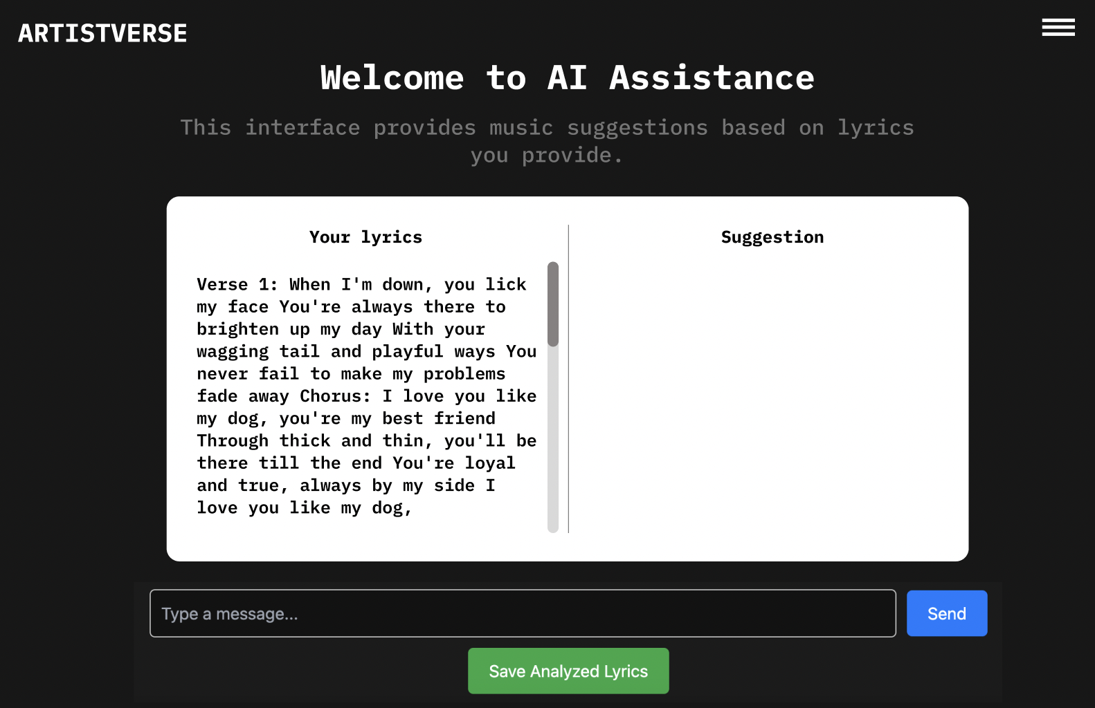
Document  Name | Artistverse-TestRecord  V.3.0 | Owner | NS , WS | Page | 71
Document  Type | Test Record | Release Date | 11/10/2024 | Print date | 11/10/2024

3. Verify the system displays analysis results.
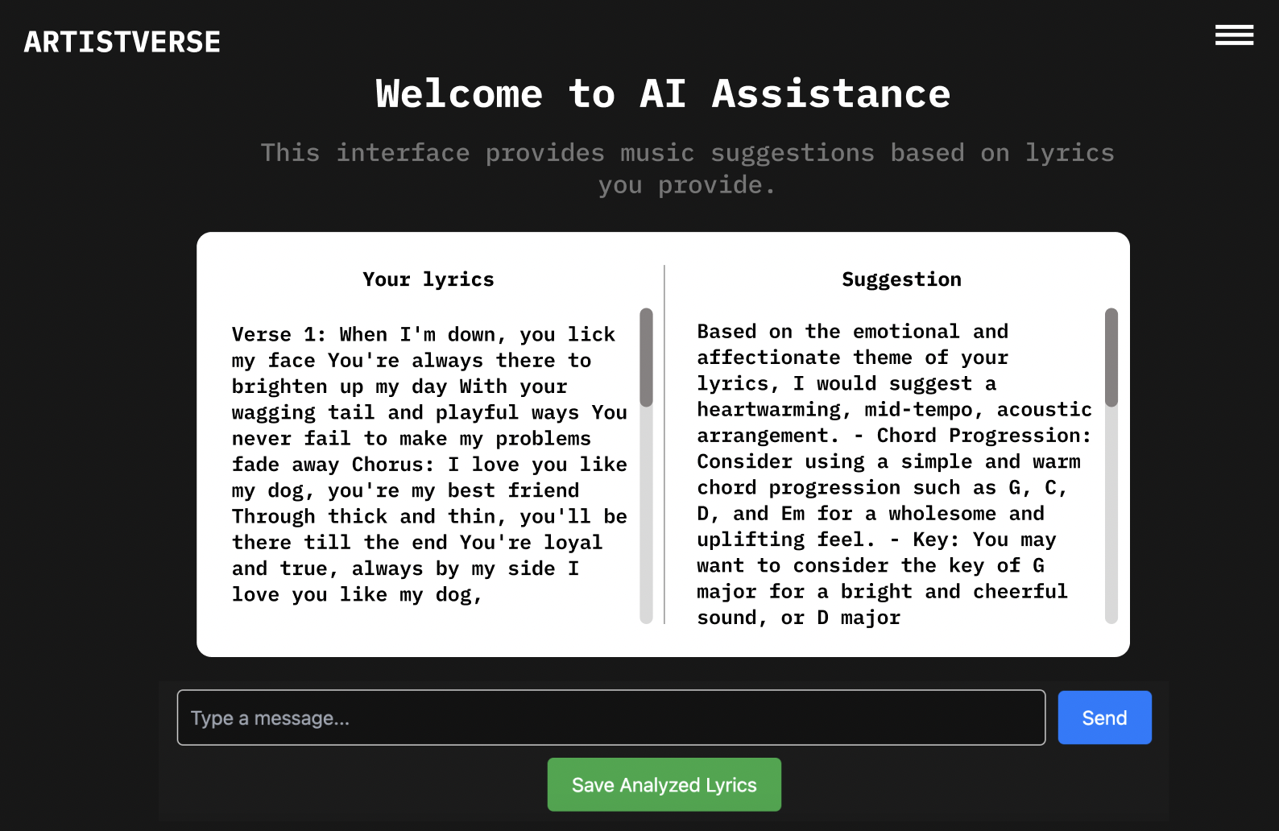
Test case:
No | Description | Input | Expected Result | Result
1 | Input valid  lyrics and  analyze | [Verse 1] Whenyou were here  before Couldn'tlook you in the  eye You're just  like an angel  Your skin  makes me cry  You float like afeather In a  beautiful worldI wish I was  special You're  so fuckin'  special [Chorus]But I'm a creep,I'm a weirdo  What the hell  am I doin' here?I don't belong  here [Verse 2] Idon't care if it  hurts I wanna  have control I | "analysis": "Your  lyrics suggest a  sense of longing  and an  introspective,  melancholic mood.Here's a suggestionfor a musical  interpretation:\n\n-Chords: The song  could be  accompanied by  simple, arpeggiatedchords, such as G,  B, C, and Cm, to  capture the  emotional depth ofthe lyrics.\n\n- Key:The song could be  in the key of G  major, providing a  melancholic yet  hopeful feel.\n\n-  Time Signature: | pass

Document  Name | Artistverse-TestRecord  V.3.0 | Owner | NS , WS | Page | 72
Document  Type | Test Record | Release Date | 11/10/2024 | Print date | 11/10/2024

 |  | want a perfect  body I want a  perfect soul I  want you to  notice When I'mnot around  You're so  fuckin' special Iwish I was  special [Chorus]But I'm a creep,I'm a weirdo  What the hell  am I doin' here?I don't belong  here Oh-oh,  oh-oh | The lyrics lend  themselves well toa 4/4 time  signature, allowingfor a comfortable  and natural flow ofthe melody.\n\n-  Tempo: A slow  tempo, around  60-70 beats per  minute, would  enhance the  emotional impact ofthe lyrics and the  contemplative  nature of the  song.\n\n- MusicalInformation: The  verses could featurea minimalistic,  gentle guitar  arpeggio  accompanied by a  melancholic vocal  melody. The chorusmight build with a  slightly fuller  arrangement,  adding gentle  percussion and  additional  instrumentation to  convey the  emotional intensity.Overall, the music  should capture the  vulnerability and  longing expressed  in the lyrics."

Document  Name | Artistverse-TestRecord  V.3.0 | Owner | NS , WS | Page | 73
Document  Type | Test Record | Release Date | 11/10/2024 | Print date | 11/10/2024

STC-16: Handle Empty Lyrics Input
Description: This test verifies that the system correctly handles empty lyrics input bydisplaying an error message.
Prepared Data: None
Test script:
1. Leave the lyrics input field empty.

2. Click "Send" to trigger analysis.
3. Verify the system displays an error message.
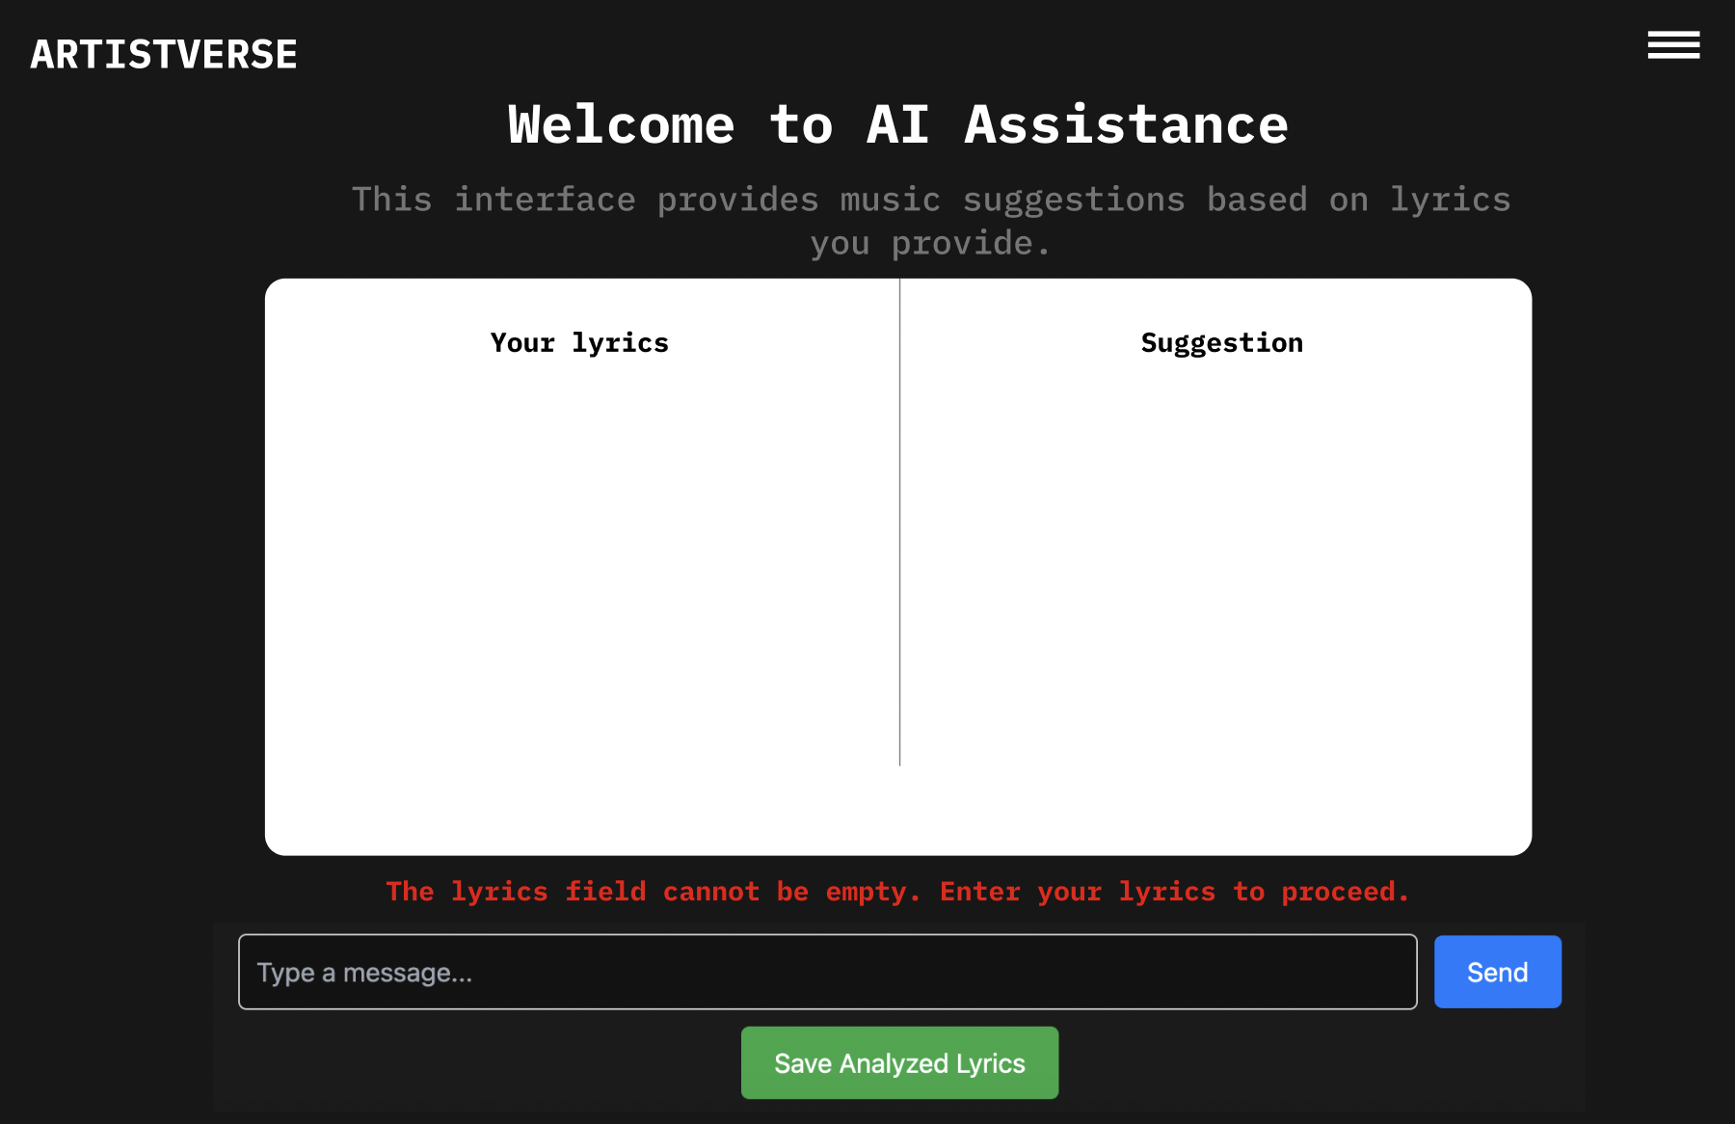
Document  Name | Artistverse-TestRecord  V.3.0 | Owner | NS , WS | Page | 74
Document  Type | Test Record | Release Date | 11/10/2024 | Print date | 11/10/2024

Test case:
No | Description | Input | Expected Result | Result
1 | Attempt to  analyze withoutinput lyrics | “” | Error message: "The  lyrics field cannot be  empty. Enter your lyricsto proceed." | pass

Document  Name | Artistverse-TestRecord  V.3.0 | Owner | NS , WS | Page | 75
Document  Type | Test Record | Release Date | 11/10/2024 | Print date | 11/10/2024

STC-17: Save Analyzed Lyrics to Local File
Description: This test verifies that the analyzed lyrics can be saved to the localcomputer
Prepared Data: Analyzed lyrics available.
Test script:
1. Perform lyrics analysis.

2. Click "Save" to save the analyzed lyrics.
3. Verify the lyrics are saved as a .txt file.
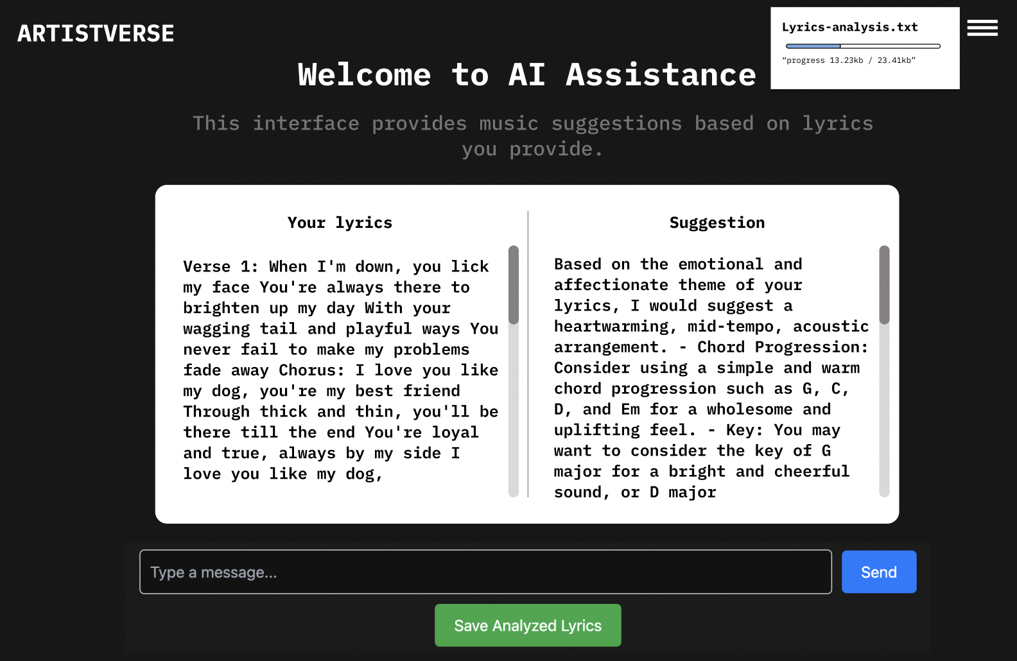
Document  Name | Artistverse-TestRecord  V.3.0 | Owner | NS , WS | Page | 76
Document  Type | Test Record | Release Date | 11/10/2024 | Print date | 11/10/2024

Test case:
No | Description | Input | Expected Result | Result
1 | Save analyzed  lyrics to local  storage | None | Lyrics saved as a .txt  file on the local  computer. | pass

Document  Name | Artistverse-TestRecord  V.3.0 | Owner | NS , WS | Page | 77
Document  Type | Test Record | Release Date | 11/10/2024 | Print date | 11/10/2024

STC-18: No Internet Connection Handling
Description: This test verifies that the system displays an error message when there isno internet connection during analysis or saving.
Prepared Data: None
Test script:
1. Disconnect from the internet.
2. Input lyrics and click "Send".

3. Click "Save" to save analyzed lyrics.

4. Verify the system displays appropriate error messages.
Document  Name | Artistverse-TestRecord  V.3.0 | Owner | NS , WS | Page | 78
Document  Type | Test Record | Release Date | 11/10/2024 | Print date | 11/10/2024

Test case:
No | Description | Input | Expected Result | Result
1 | Attempt to  analyze lyrics  without internet | [Verse 1] Whenyou were here  before Couldn'tlook you in the  eye You're just  like an angel  Your skin  makes me cry  You float like afeather In a  beautiful worldI wish I was  special You're  so fuckin'  special [Chorus]But I'm a creep,I'm a weirdo  What the hell  am I doin' here?I don't belong  here [Verse 2] Idon't care if it  hurts I wanna  have control I  want a perfect  body I want a  perfect soul I  want you to  notice When I'mnot around  You're so  fuckin' special Iwish I was  special [Chorus]But I'm a creep,I'm a weirdo  What the hell  am I doin' here?I don't belong  here Oh-oh,  oh-oh | Error message: "No  internet connection." | pass

Document  Name | Artistverse-TestRecord  V.3.0 | Owner | NS , WS | Page | 79
Document  Type | Test Record | Release Date | 11/10/2024 | Print date | 11/10/2024

2 | Attempt to saveanalyzed lyrics  without internet | None | Error message: "No  internet connection." | pass

Document  Name | Artistverse-TestRecord  V.3.0 | Owner | NS , WS | Page | 80
Document  Type | Test Record | Release Date | 11/10/2024 | Print date | 11/10/2024

Appendix A
Appendix: Spotify_track
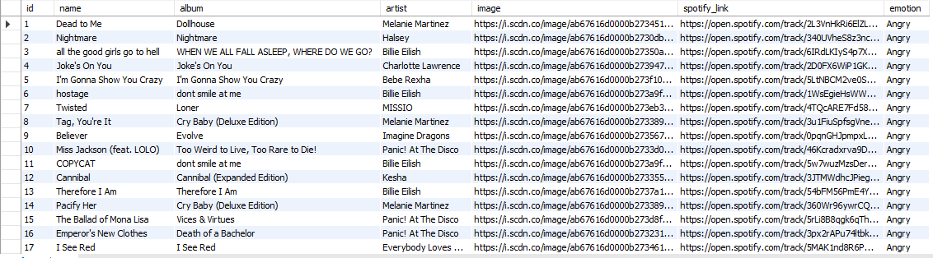
Document  Name | Artistverse-TestRecord  V.3.0 | Owner | NS , WS | Page | 81
Document  Type | Test Record | Release Date | 11/10/2024 | Print date | 11/10/2024

